

RICHARD THOMPSON RETURNS WITH HIPPIES, THUGS AND HEROES OCTOBER 16, 2026 VIA NEW WEST RECORDS
SHARES “COCAINE WALKING, BOOZE TALKING” TODAY

“The finest rock songwriter after Dylan and the best electric guitarist since Hendrix” - The Los Angeles Times
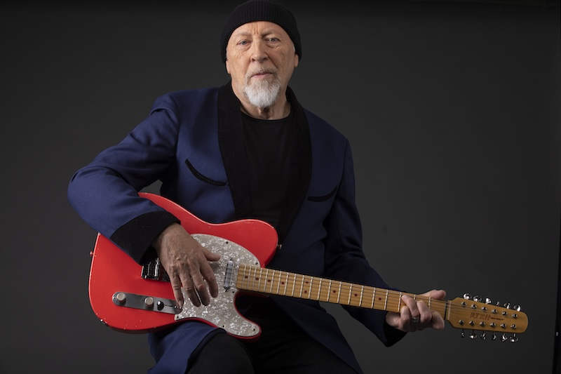
Richard Thompson Photograph by David Kaptein
Richard Thompson will release his 20th Studio Album, Hippies, Thugs and Heroes on October 16, 2026 via New West Records. The 12-track set was produced by Thompson and James Frazee and recorded in Weehawken, New Jersey. It follows his acclaimed Ship to Shore, which the Associated Press called “a gem,” NPR Music described as “expertly constructed, absolutely bleak yet totally engaging trad-rock from the 75-year old master” and Uncut Magazine named one of the “Best Albums of 2024.” The influential singer-songwriter and virtuosic guitarist has been on a singular musical journey for over a half century, from his days in the ‘60s as a pioneer of British folk rock with Fairport Convention, to his seminal ‘70s duo work with his ex-wife Linda Thompson, to the exploratory, deeply emotional music of the solo career that has been his primary concern ever since.

The gritty and immediate Hippies, Thugs and Heroes never settles into one style or mood or setting, but shows so many different sides of Thompson as a songwriter, singer, guitarist, and bandleader. It showcases a motley cast of characters: old friends and false gurus, beloved musicians and former selves, hippies, thugs, and heroes—some true to life and others dreamed up wholecloth. They all climbed out of some deep recess of Thompson’s mind and insisted he tell their stories. As he finished recording, Thompson found that all of these disparate songs and desperate characters formed an album that is both coherent and daring, familiar yet new: a feat of songwriting and storytelling. He says, “You look over the body of songs you’ve written and ask yourself, Which ones are kindred spirits? You look for commonality among the songs, and it’s also a joy when you realize that certain songs seem to be brothers and sisters..”

Today, Thompson shared the first single, “Cocaine Walking, Booze Talking,” a hardscrabble tale of folks hustling in London—a “carousel queen” overwhelmed by the big city, a soldier quoting Shakespeare, “a Kings Road Hippie,” and a “Sauchiehill thug.” It features some of his most subtly inventive guitar playing: a series of strutting, raw-nerve riffs culminating in a splintered and psychedelic solo. Hear it HERE.

Thompson wrote and demo’ed songs for his backing band, which includes Taras Prodaniuk on bass, Michael Jerome on drums, David Mansfield on guitar and fiddle, and his wife Zara Phillips on backing vocals. His home recordings were much more elaborate, much more specific for the new album. “It’s so much fun to mess around at home and disappear down in the basement for hours at a time. I even bought myself a drumkit. So I was able to present more complete demos to the band. You could say there’s much more of my identity being transferred to the final product.” As always, he left room for the band to add their own ideas, but admits Hippies, Thugs and Heroes is “less them and more me. But I’m never strict about what I want to hear on a record. I’m always interested to see what they come up with, and I always want to see where a song takes me.” Thompson and the band convened at Hobosound Studio in Weehawken, New Jersey, located a stone’s throw from his own home. “I think this is why this album came together so quickly. We could just steam through at high speed and not labor over everything.” The small crew recorded live with a minimum of takes—sometimes as few as two, but rarely more than four.” That approach lends to its sense of urgency.

Richard Thompson’s musical influence cannot be overstated. Having co-founded the groundbreaking group Fairport Convention as a teenager in the ‘60s, he and his bandmates invented their distinctive strain of British Folk Rock. Thompson left the group by the age of 21 and embarked upon a decade long musical partnership with his then-wife Linda, followed by over 30 years as a highly successful solo artist. In 2011, Thompson received an OBE from the late Queen Elizabeth II at Buckingham Palace.
Among his many accolades, the Los Angeles Times called him “the finest rock songwriter after Dylan and the best electric guitarist since Hendrix” and Rolling Stone named him one of the Top 100 Guitarists of All Time. He has received lifetime achievement awards for songwriting from the BBC Radio 2 Folk Awards, the Americana Music Association, and the prestigious Ivor Novello Awards. His song “1952 Vincent Black Lightning” was named one of TIME Magazine’s “100 Greatest Songs Since 1923.”
A wide range of musicians have recorded Thompson’s songs including Robert Plant, Elvis Costello, R.E.M., Sleater-Kinney, Del McCoury, Bonnie Raitt, Tom Jones, David Byrne, Don Henley, Los Lobos, and many more. His massive body of work includes countless Grammy-nominated albums as well as numerous soundtracks, including Werner Herzog’s Grizzly Man and 2019’s The Cold Blue.

Thompson’s genre defying mastery of both acoustic and electric guitar, along with engaging energy and onstage wit, continue to earn him new fans and cement his place as one of the most distinctive virtuosos and writers in Folk Rock History.

Richard Thompson’s Hippies, Thugs and Heroes will be available across digital platforms, compact disc, and standard black vinyl. A limited Clear with Black Splatter color vinyl edition with an autographed insert as well as a limited compact disc edition autographed by Richard Thompson will be available at Independent Retailers. A limited pink marbled color vinyl edition including a bonus flexi-disc featuring a demo recording of “Cocaine Walking, Booze Talking,” and an autographed insert will be available via Rough Trade. A limited yellow with black splatter color vinyl edition including an autographed insert as well as a limited & autographed compact disc edition is available for pre-order NOW via NEW WEST RECORDS.
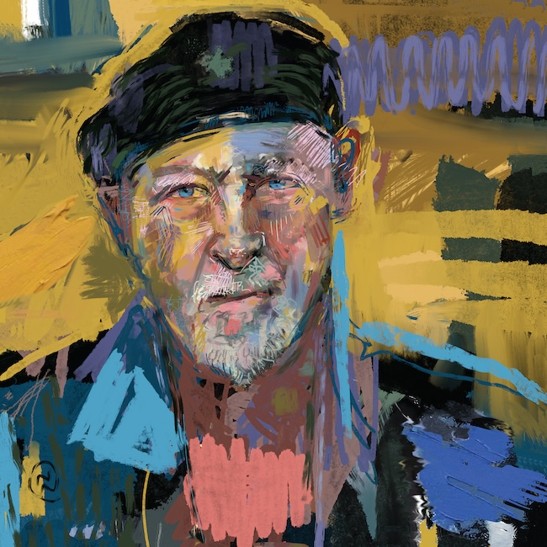
Hippies, Thugs and Heroes Track Listing:

1. Sorcerer’s Apprentice
2. Cocaine Walking, Booze Talking
3. Pauper’s Grave
4. Unsung Hero
5. Make Believe You Don’t Know Me
6. She Burns It All
7. Everybody’s Stealing
8. The Soul In Me
9. Pipe Dreams
10. The Big Smoke
11. Stringer
12. Siren

Richard Thompson On Tour:

August 2 - Cambridge Folk Festival 2026 - Cambridge, United Kingdom
August 14 - Fairport Cropredy Convention 2026 - Banbury, United Kingdom
August 21 - St Georges Church Hall - Beckenham, United Kingdom
August 22 - FolkEast 2026 -Beccles, United Kingdom
August 23 - Beautiful Days 2026 - Ottery St Mary, United Kingdom
September 4 - Buxton Opera House - Buxton, United Kingdom
September 10 - Lighthouse Poole, United Kingdom
September 11 - Subscription Rooms Stroud, United Kingdom
September 12 - Bromyard Folk Festival 2026 Bromyard, United Kingdom
September 13 - Wiltshire Music Centre -Bradford-on-Avon, United Kingdom
November 20 - Elkton Music Hall - Elkton, MD, United States
November 21 - Outpost in the Burbs’ Concert for Toni’s Kitchen - Montclair, NJ, United States
www.RichardThompson-Music.com
www.NewWestRecords.com
For More Information, Please Contact:
Brady Brock | New West Records | bradybrock@newwestrecords.com

