May 18, 2026
For Immediate Release

mary in the junkyard Release New Single/Video, “New Muscles,”
& Announce North American Headline Tour;

Co-Headlining Shows with Dove Ellis in Los Angeles on May 27th/28th
& New York City on May 30th/31st

Debut Album, Role Model Hermit, out July 3rd via AMF Records
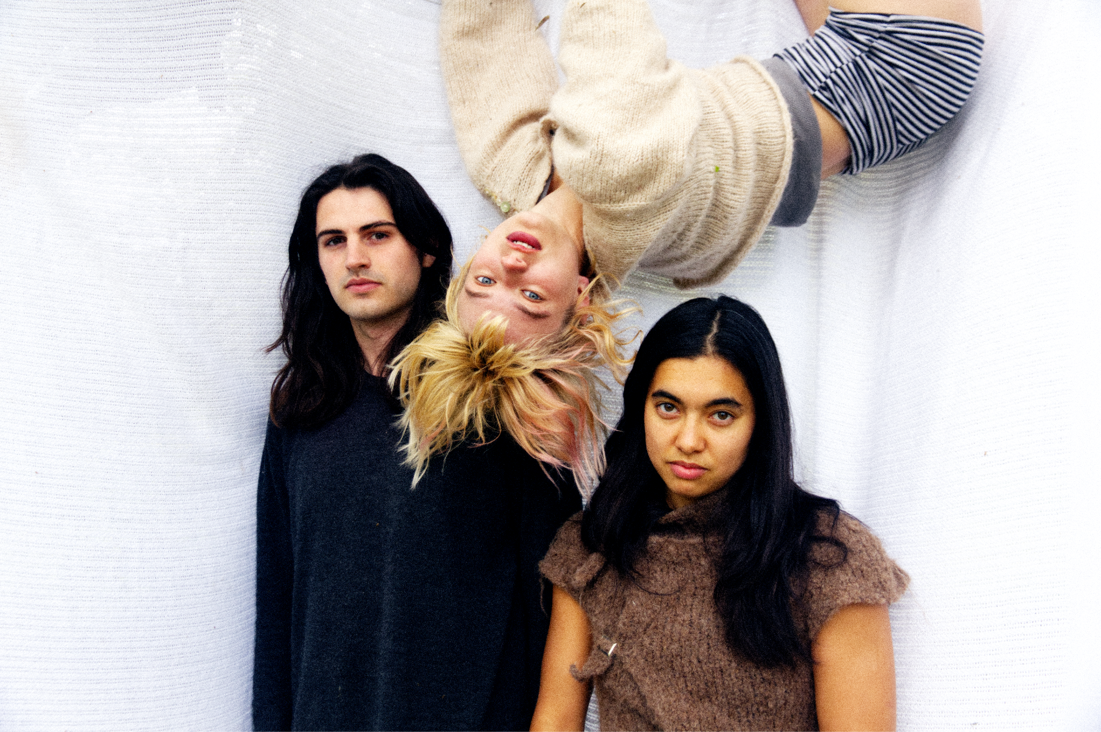
Photo Credit: Xander Lewis

mary in the junkyard — Clari-Freeman Taylor (vocals, guitar, cello, viola, violin), Saya Barbaglia (Bass, viola, violin, backing vocals) and David Addison (drums) — release the new single/video, “New Muscles,” from their debut album, Role Model Hermit, out July 3rd via AMF Records. In conjunction, they announce a North American headline tour. Tickets go on sale on Friday, May 22nd and will be available here.

Following the hushed “Candelabra” and the winding ballad “Crash Landing,” “New Muscles” reveals a lighter side of the band, while still retaining their sense of melodic invention. The track is structured around a playful melody and rolling percussion courtesy of Addison. “New Muscles” has been in rotation in the band’s live set and became a fan favorite when they supported Wet Leg on their 2025 US tour. mary in the junkyard comment, "’New Muscles’ was originally composed on the accordion, we wrote it about David joining a gym."

The video was shot in South-East London and devised by the band, with both Barbaglia and Freeman-Taylor learning Muay Thai for the shoot. Freeman-Taylor and Barbaglia say, "The fight in the video is real and we trained for it for a combined year (Saya 1 year, Clari 1 month).” Every extra and member of the crew is also a part of the band’s wider creative circle, illustrating the band’s tight connection to their DIY roots.

Watch the Video for “New Muscles”

“New Muscles” Video Still

Role Model Hermit is a collection of dark fables, intricate melodies and moments of revelation. mary in the junkyard wrote the album between the UK and US and recorded it in London during the summer of 2025 with producer Oli Bayston (Boxed In). Throughout its runtime, the album walks the line between fact and fiction with a real sense of bite and moments of poignancy, while always creeping into the phantasmagoric.

Role Model Hermit showcases a band with full belief in their abilities. As The Face predicted, “mary in the junkyard’s breakout moment beckons.” From extensive tours of the UK and Europe, to a three month North American run supporting Wet Leg where they road tested the new songs, plus a recent KEXP session, mary in the junkyard have been carefully building up to this.

Leading up to the album release, mary in the junkyard will play a run of co-headline dates with Dove Ellis at the Hollywood Forever Cemetery in Los Angeles on May 27th and 28th and the Bowery Ballroom in New York City on May 30th and 31st. This summer, they will play several in-store performances in the US and UK. The band’s newly announced tour finds them making stops in major cities across North America this fall.

Pre-Order Role Model Hermit

Listen to “Candelabra”

Watch the Acoustic Video for “Candelabra”

Watch the Video for “Crash Landing”

mary in the junkyard Tour Dates
(New Dates in Bold)
Wed. May 27 - Los Angeles, CA @ Hollywood Forever Cemetery +
Thu. May 29 - Los Angeles, CA @ Hollywood Forever Cemetery +
Sat. May 30 - New York, NY @ Bowery Ballroom +
Sun. May 31 - New York, NY @ Bowery Ballroom +
Thu. July 2 - Kingston, UK @ Banquet Records *
Fri. July 3 - Brighton, UK @ Resident *
Sat. July 4 - London, UK @ Rough Trade East *
Sun. July 5 - Bristol, UK @ Rough Trade Bristol *
Mon. July 6 - Nottingham, UK @ Rough Trade Nottingham*
Tue. July 7 - Liverpool, UK @ Rough Trade Liverpool *
Wed. July 8 - Leeds, UK @ Vinyl Whistle *
Thu. July 9 - Manchester, UK @ HMV Manchester *
Fri. July 10 - Glasgow, UK @ Assai Glasgow *
Tue. Sept. 22 - Dublin, IRE @ The Grand Social
Wed. Sept. 23 - Belfast, NI @ Ulster Sports Club
Fri. Sept. 25 - Edinburgh, UK @ Cabaret Voltaire
Sat. Sept. 26 - Leeds, UK @ Brudenell Social Club
Sun. Sept. 27 - Birmingham, UK @ Hare and Hounds
Tue. Sept. 29 - Manchester, UK @ Gorilla
Wed. Sept. 30 - London, UK @ Heaven
Thu. Oct. 1 - Bristol, UK @ Exchange
Fri. Oct. 2 - Hitchin, UK @ Club 85
Mon. Oct. 5 - Paris, FR @ La Bellevilloise
Tue. Oct. 6 - Brussels, BE @ Botanique - The Rotonde
Wed. Oct. 7 - Rotterdam, NL @ Rotown
Thu. Oct. 8 - Amsterdam, NL @ Bitterzoet
Mon. Nov. 2 - Los Angeles, CA @ Zebulon
Wed. Nov. 4 - San Francisco, CA @ Rickshaw Stop
Fri. Nov. 6 - Portland, OR @ Mississippi Studios
Sat. Nov. 7 - Seattle, WA @ Barboza
Tue. Nov. 10 - Minneapolis, MN @ 7th St Entry
Wed. Nov. 11 - Chicago, IL @ Empty Bottle
Fri. Nov. 13 - Toronto, ON @ The Garrison
Sat. Nov. 14 - Montreal, QC @ Petit Campus
Wed. Nov. 18 - Brooklyn, NY @ Baby’s All Right
Fri. Nov. 20 - Washington, DC @ DC9
Sat. Nov. 21 - Philadelphia, PA @ PhilaMOCA

* In-Store Performance
+ = Co-headline with Dove Ellis

Download hi-res images of mary in the junkyard


Role Model Herrmit Album Artwork

mary in the junkyard Online
Website | Instagram | Bandcamp

For more information, please contact:
Jessica Linker & Matt Grimm | Pitch Perfect PR –
jessica@pitchperfectpr.com, matt@pitchperfectpr.com

###

