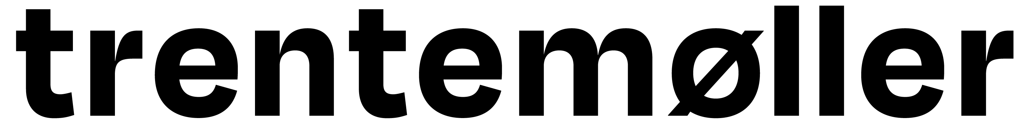

Trentemøller has mesmerised his live audiences with his unique soundscapes and memorable melodies over the last two decades. With more than 500 shows worldwide, he has established himself as a true master of his craft. His music represents a continuously evolving series of themes and ideas, and his shows consistently push the limits of what we expect from live music.

Whether you're a long-time fan or new to his work, Trentemøller's live performances are not to be missed. So don't hesitate - join him and his band in 2025 and experience the magic for yourself.

The band features Emma Acs on vocals, and synths, Silas Tinglef on drums and guitar, Brian Batz on guitar, Jacob Haubjerg on bass, and Anders Trentemøller on synths.

Short bio:

Copenhagen-based Trentemøller has, over the last 25 years, achieved critical acclaim for his unique soundscapes and memorable melodies. Trentemøller's music represents a constantly evolving series of themes and ideas, with each release representing the next chapter of his artistic journey. He explores contrasts and paradoxes in his work and acknowledges these themes in his albums. Trentemøller's music often revolves around reminiscence and remembrance, yet he avoids nostalgia by infusing his tracks with contemporary elements. His debut full-length album, The Last Resort, was released in 2006 after a run of EPs. It topped several end-of-year polls and exposed Trentemøller's music to a broader audience.

Trentemøller is set to release new album in September. "Dreamweaver" weaves together 10 new, mesmerizing songs. The single "A Different Light" will be released on May 17th and will also be the lead track on "Dreamweaver," Trentemøller's first full-length album since 2022's "Memoria."

In recent years, Trentemøller has also remixed music by artists like Tricky, Savages, Depeche Mode, Franz Ferdinand, The Knife, A Place To Bury Strangers, Soft Moon, UNKLE, adding to a list of over a hundred previously released remixes.

Studio albums:

The Last Resort (2006)

Into The Great Wide Yonder (2010)

Lost (2013)

Fixion (2016)

Obverse (2019)

Memoria (2021)

Dreamweaver (2024)