FOR IMMEDIATE RELEASE
June 25, 2019

JAIME,
BRITTANY HOWARD’s DEBUT SOLO ALBUM,
SET FOR SEPTEMBER 20 RELEASE ON ATO RECORDS

Howard Shares The First Track, “History Repeats”

Fall North American Tour Announced; Tickets Go On Sale This Week

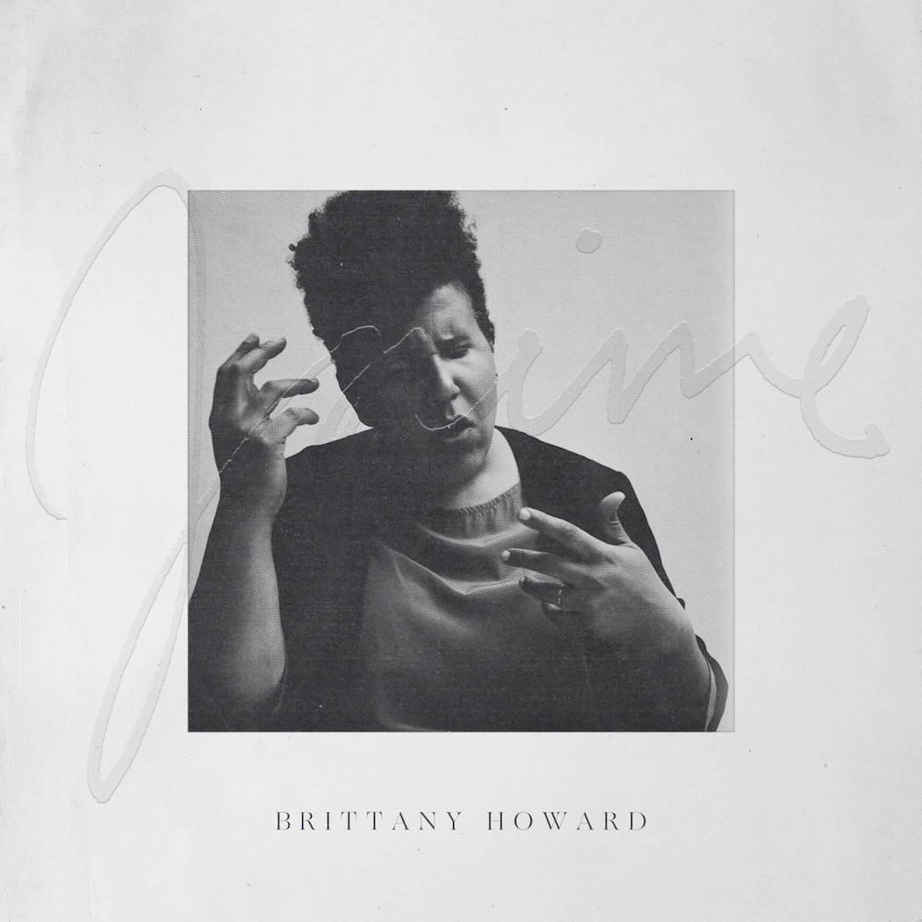
Pre-Order Jaime HERE

Brittany Howard – lead vocalist/guitarist for the chart-topping, GRAMMY®-winning band Alabama Shakes – will release her debut solo album, Jaime, on September 20 via ATO Records. Today, she shared the leadoff track, “History Repeats.” Download “History Repeats” HERE and listen HERE. Pre-order Jaime HERE.

“‘History Repeats’ is as much a personal song as it is a song about us as a human species. Our times of success may propel us forward, but our repeating failures hold us back from evolving into harmony,” says Brittany Howard, who posted her mission statement for the album earlier today. See below for links to her social media.

Howard will support the album with a North American tour, which includes two-night stands at intimate venues in Asheville, NC, Washington, DC and Los Angeles. The headline run will also include shows at Ryman Auditorium in Nashville (August 19) and New York City’s Beacon Theatre (September 24). See below for full itinerary. Howard and her band made their live debut last week at the prestigious Cannes Lions International Festival of Creativity.

The fan ticket presale begins today at 10:00 AM local time. Tickets go on sale to the public on Friday, June 28, at 10:00 AM local time unless otherwise noted below. Every online ticket purchased for the U.S. dates on the fall tour will include a CD of the new album, Jaime.

Citi is the official presale credit card of the Brittany Howard 2019 North American tour. As such, Citi cardmembers will have access to purchase presale tickets beginning today at 10:00 AM through Thursday, June 27, at 10:00 PM local time through Citi EntertainmentSM. For complete presale details visit www.citientertainment.com.

Howard recorded Jaime after a cross country drive that took her from Nashville to a small house in Topanga, CA – a rustic Los Angeles county town wedged between the mountains and the beach. She titled the album after her sister, who taught her to play the piano and write poetry, and who died of cancer when they were still teenagers.

“The title is in memoriam, and she definitely did shape me as a human being,” says Brittany Howard. “But, the record is not about her. It’s about me. I’m pretty candid about myself and who I am and what I believe. Which is why I needed to do it on my own.”

While Howard admits it was daunting, stepping out alone from her work with Alabama Shakes and revealing so much of herself, it was a necessary step. “I turned 30 and I was like, ‘What do I want the rest of my life to look like?’” she recalls. “Do I want to play the same songs until I’m 50 and then retire, or do I do something that’s scarier for me? Do I want people to understand me and know me, do I want to tell them my story? I’m very private, but my favorite work is when people are being honest and really doing themselves.”

She brought a handful of finished songs into engineer Shawn Everett’s L.A. studio. Once she started working with the band she had assembled – a core group of Alabama Shakes bassist Zac Cockrell, innovative jazz-based keyboard player Robert Glasper and drummer Nate Smith – the music started to take shape. Different sounds and approaches began to emerge. Howard examines spiritual ritual on “He Loves Me” and celebrates love with “Georgia.” “Goat Head” is informed by the experience of growing up as a mixed-race child in the South while “13th Century Metal” grew out of Glasper and Smith jamming in the studio. See below for track listing.

As the frontwoman and guitarist for Alabama Shakes, Howard has become one of music’s most celebrated figures. The band has won four GRAMMY Awards and topped the Billboard 200 with the Gold-certified Sound & Color, the follow-up to its Platinum debut album, Boys & Girls. Howard has performed everywhere from the Obama White House to the main stage at Lollapalooza, where she sang with Paul McCartney at his invitation. In between albums and tours with Alabama Shakes, Howard grows restless. “To me, there is no time off – I’m a creative person and I need to create, or I just feel weird, not fully human,” she says. She’s channeled that relentless creativity into Jaime, her most revelatory work yet.

Brittany Howard Photo Credit: Danny Clinch

Jaime – Track Listing
- History Repeats
- He Loves Me
- Georgia
- Stay High
- Tomorrow
- Short and Sweet
- 13th Century Metal
- Baby
- Goat Head
- Presence
- Run To Me

Brittany Howard – North American Tour
Tickets go on sale to public Friday, June 28, at 10:00 AM local time, unless otherwise noted.
* Tickets on sale Friday, June 28, at 12:00 PM
** Tickets on sale Thursday, June 27, at 10:00 AM

8/17 | Asheville, NC | Orange Peel *
8/18 | Asheville, NC | Orange Peel *
8/19 | Nashville, TN | Ryman Auditorium
8/23 | Washington, DC | 9:30 Club **
8/24 | Washington, DC | 9:30 Club **
9/18 | Milwaukee, WI | Riverside Theater
9/19 | St. Paul, MN | Palace Theatre
9/20 | Chicago, IL | Riviera Theatre
9/22 | Toronto, ON | Rebel
9/24 | New York, NY | Beacon Theatre
9/25 | Boston, MA | House of Blues
9/27 | Philadelphia, PA | The Fillmore
10/5 | Austin, TX | ACL Festival – tickets on sale now
10/8 | Los Angeles, CA | Theatre at Ace Hotel
10/9 | Los Angeles, CA | Theatre at Ace Hotel
10/12 | Austin, TX | ACL Festival– tickets on sale now
10/13 | Atlanta, GA | AfroPunk Festival – tickets on sale now

###
For more information on Brittany Howard, contact:

Ambrosia Healy, Capitol Music Group / Ambrosia.Healy@umusic.com
Erin Cooney, Capitol Music Group / Erin@umusic.com

or visit:

www.brittanyhoward.com
Instagram @blackfootwhitefoot
Twitter @blkfootwhtfoot
Facebook.com/BrittanyHowardOfficial

