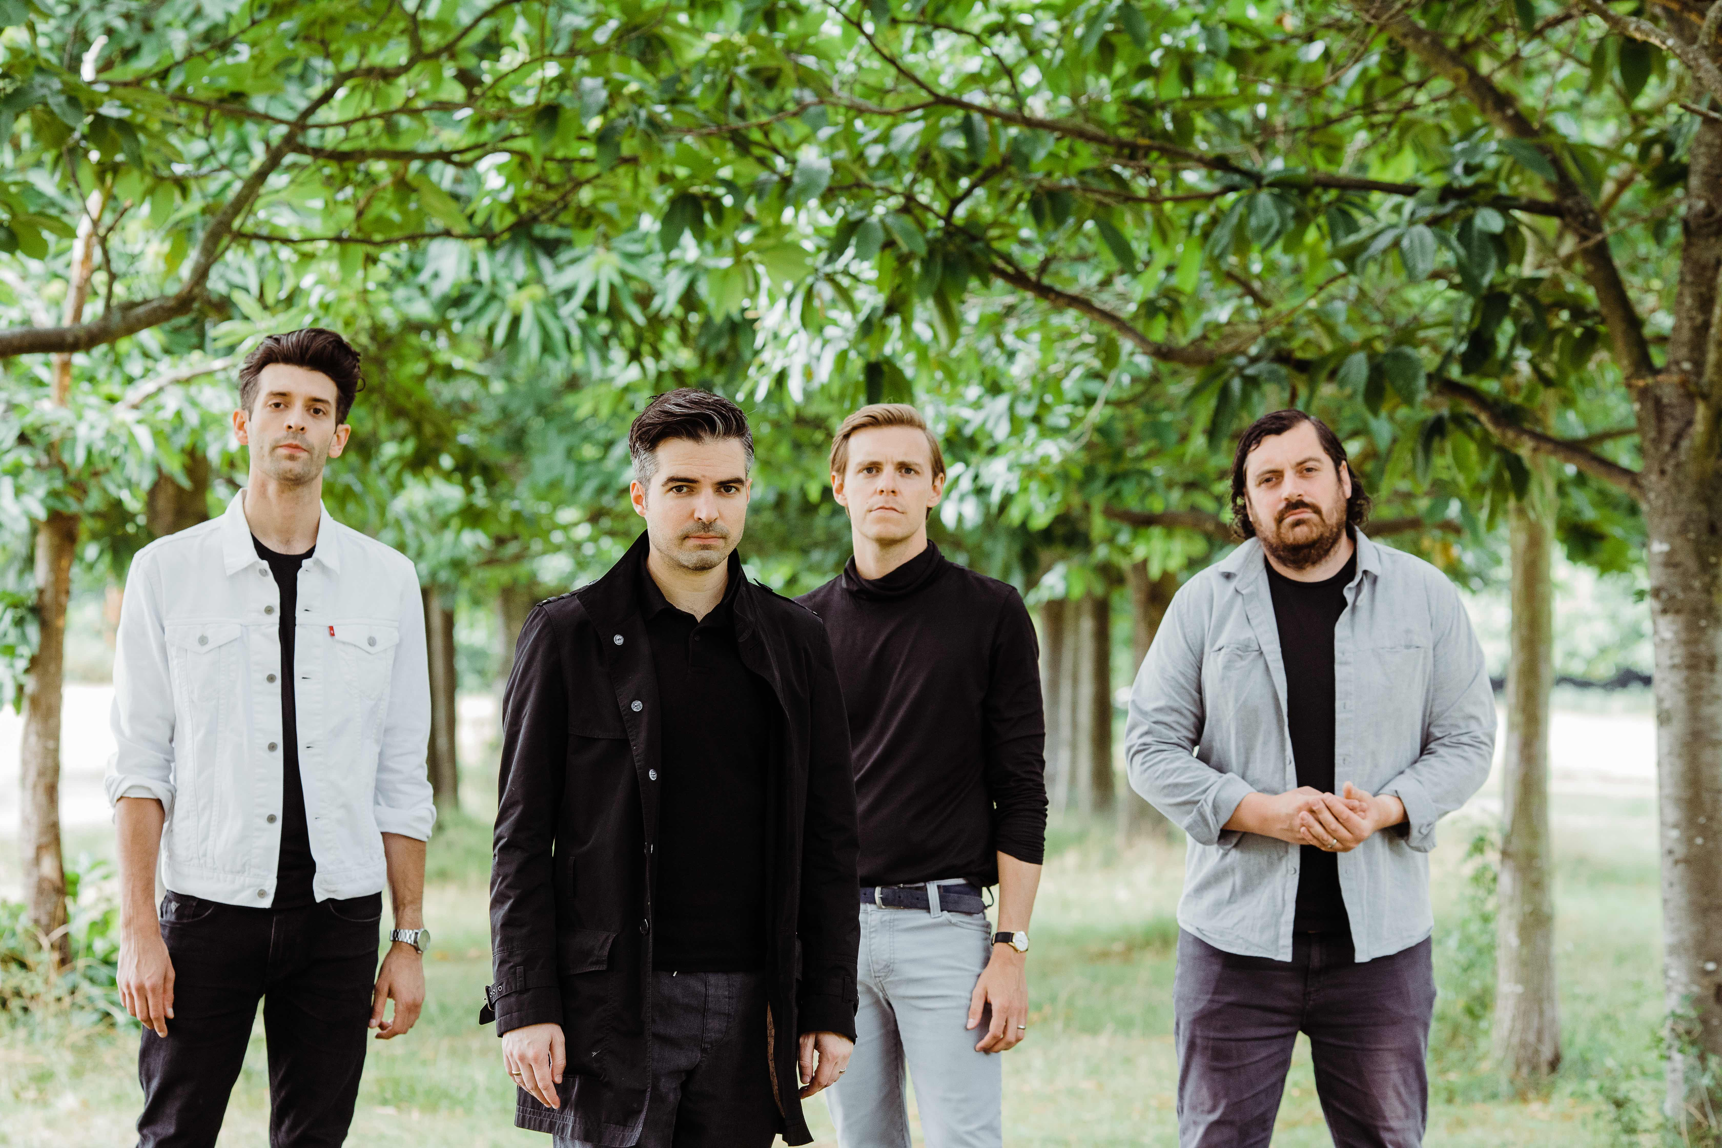

ANNOUNCE 6th STUDIO ALBUM

‘GHOST ALIVE’

The Boxer Rebellion today announce the imminent arrival of their 6th studio album ‘Ghost Alive,’ which will be released on 23rd March via the band’s own label, Absentee Recordings. This new record presents a very delicately crafted collection of songs which are both tender and immensely courageous in equal measure.

‘Ghost Alive’ is a celebration of the positive impact on oneself and others that can, ultimately, be realised from even the most challenging of human experiences. “On this record we dealt with delicate emotions out in the open,” states the band’s lead guitarist and principle arranger, Andrew Smith. “We wanted to communicate this personal vulnerability by underpinning Nathan’s lyrics with orchestral textures.”

“This album was certainly born during a particularly challenging time for my family and I,” says frontman Nathan Nicholson. “Late one evening - right in the middle of pre-production - I was informed by telephone of my Dad’s passing. I was in London with my wife and son, and left first thing in the morning to fly back to Maryville, Tennessee, where I'm from.”

“When I returned to London I felt I had some sort of out-of-body experience - I came back with a different point of view, and all the unimportant shit in my life just faded away. Often fans come up to us after a show and tell us their personal feeling of a song, which is usually a wildly different interpretation than whatever I might have written about. That’s the really wonderful thing about songs - they can be deeply personal, and whatever the listener takes away from that one piece of music is what counts. What is different about this record - this particular group of songs - is that they mean something completely different to me since my dad died. I almost feel like I’ve become the listener rather than the songwriter, and these songs mean more to me now than when they were written.”

“Rather than stripping back, we wanted to maximise the full power of emotive instruments on this album,” says Smith. “We achieved big, immersive, sweeping sounds that we’ve never been associated with before, but also delivered on heightening the sincerity and intimacy of the lyrics. We wanted to represent these emotions sonically with different colours, and of course strings and horns played a significant part in this.” Smith spent a lot of time focussing on these arrangements, and with bassist Adam Harrison, and drummer Piers Hewitt, the four members of The Boxer Rebellion set about crafting the album’s presentation with co-producer Adam ‘Cecil’ Bartlett.

“We played very sensitively on this album, and given what Nathan had just gone through, I think we connected dynamically with each other in a way we have never done before,” says Harrison. “It was a very cathartic and uplifting experience for us all, and I think anyone who listens to this album will feel that immediately.”

Nicholson agrees: “Ghost Alive is an album that has become immensely comforting to me personally, and one that would never have been what it is without loss. I sincerely hope many others will get the same feelings of love and support from this album as I do.”

GHOST ALIVE  Released 23rd March  Track listing:  - What The Fuck  - Rain  - Love Yourself  - Fear  - Here I Am  - Don’t Look Back  - Lost Cause  - Don’t Ever Stop  - River  - Under Control  - Goodnight | 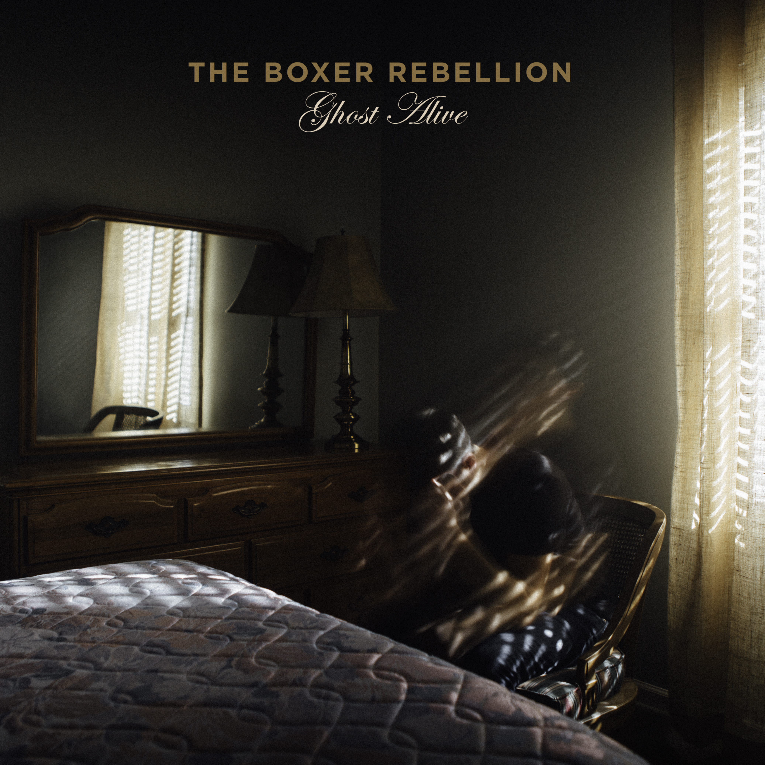

TheBoxerRebellion.com | Facebook | Twitter | Instagram

