March 26, 2018
For Immediate Release

SAM EVIAN ANNOUNCES SOPHOMORE ALBUM, YOU, FOREVER,
OUT JUNE 1ST VIA SADDLE CREEK, AND TOUR

WATCH VIDEO FOR LEAD SINGLE “HEALTH MACHINE”
http://samevian.lnk.to/YouForever

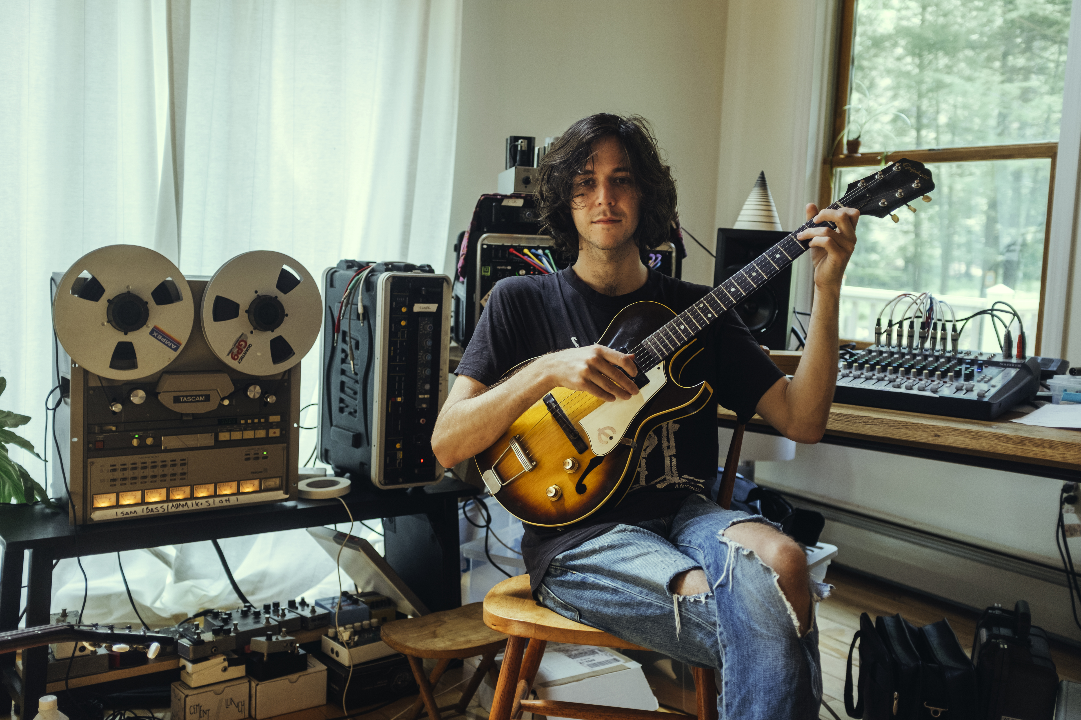
(photo credit – Josh Goleman)

"['Health Machine'] has the raw enthusiasm of an early take. It is a bludgeoning cut, driven by mottled guitars and balanced by Owens' slapback vocal, which floats as ever above the fray. Where 2016's Premium embodied an isolated vocal aloofness, 'Health Machine' is a woolly, slow-grooving production that's crowded with musicians and heavy July humidity." -- NPR Music

Sam Evian, the project of New York-based musician, songwriter, and producer, Sam Owens, will release his sophomore album, You, Forever, on June 1st via Saddle Creek. The album is available for pre-order here, including 100 limited edition LPs on yellow vinyl. Full of romance, You, Forever is Owens’s first foray into a more soul-baring sensibility following his debut album, Premium (2016), and last year’s collaboration with Chris Cohen, “Need You.” Lead single, “Health Machine,” was premiered this morning via NPR Music. It’s a crunchy, slow-burning but deliberate stomper glowing with warm electric guitar, saxophone wailing, and Owens’s reverb-laden lyrics about the unattainable health he would like to imagine for himself on tour. Something to keep in mind as the Sam Evian band tours in support of You, Forever. All dates are below. “Health Machine” is presented via a video created by Brian Betancourt, Jadon Ulrich and Owens from footage collected on journeys through the American west that inspired and informed the record.
As it has been said: no matter where you go, there you are. With You, Forever, Sam Evian is here to add some eternity to that sentiment. “This is you, forever,” he says. “It’s about accepting that you are responsible for you, that you’re in charge of your actions. Everything you do affects others and yourself, so, no matter what you choose to do, be there and learn from it.” It’s a mantra that powers Owens and is echoed across You, Forever.

You, Forever was written on the heels of touring Premium, including support runs with Whitney, Big Thief, Lucius, Luna, and Nick Hakim, all of which taught Owens much about feel and interaction. Further fueled by a desire to escape from the glow of screens and to embrace a sense of limitation, he wrote and initially recorded instrumental versions of the songs comprising You, Forever on a four-track cassette recorder using his family’s instruments in the garage where he grew up in North Carolina. He then rented a house in upstate New York with his band -- Brian Betancourt (bass), Austin Vaughn (drums), Adam Brisbin (guitar), and Hannah Cohen (backup vocals) -- to record on an eight-track reel-to-reel tape in July of 2017. Focusing on instrumental grooves and the vibe he had achieved on the original recordings, Owens found the process of limiting himself so enlightening he decided to up the ante again by banning tuning pedals from the house. “Tuning pedals make it so easy to sound good together, so when you eliminate them it takes everything back to the ’60s, which is when all my favorite records were born,” he says. “It makes everything more questionable, weird, and unruly in a really simple way.”
Watch Sam Evian’s “Health Machine” Video –
http://samevian.lnk.to/YouForever

You, Forever Tracklist:
1. IDGAF
2. Where Did You Go?
3. Health Machine
4. Anybody
5. Apple
6. Country
7. Next To You
8. Summer Day
9. Now I Feel It
10. You, Forever
11. Katie’s Rhodes

Pre-order You, Forever –
http://samevian.lnk.to/YouForever

Sam Evian Tour Dates:
Fri. Apr. 13 – Toronto, ON @ Monarch Tavern
Fri. May 18 – Brighton, UK @ The Great Escape
Sat. May 19 – Bristol, UK @ Rough Trade
Mon. May 21 – Birmingham, UK @ Hare and Hounds
Tue. May 22 – London, UK @ The Islington
Thu. May 24 – Glasgow, UK @ The Hug and Pint
Fri. May 25 – Leeds, UK @ Brudenell Social Club
Sat. May 26 – Manchester, UK @ Albert Hall #
Thu. June 7 – Boston, MA @ Great Scott *^
Fri. June 8 – Brooklyn, NY @ Rough Trade (Northside Festival) *^
Sat. June 9 – Washington, DC @ Songbyrd ^
Sun. June 10 – Durham, NC @ The Pinhook ^
Tue. June 12 – Nashville, TN @ The High Watt ^
Wed. June 13 – Bloomington, IN @ The Bishop
Thu. June 14 – Chicago, IL @ Schubas
Fri. June 15 – Millville, PA @ Mr. Small’s ^
Sat. June 16 – Philadelphia, PA @ Johnny Brenda’s ^

# = with Unknown Mortal Orchestra, Deerhunter and Khruangbin
* = with Katie Von Schleicher
^ = with Buck Meek

Download hi-res album art and press images –
www.pitchperfectpr.com/sam-evian/

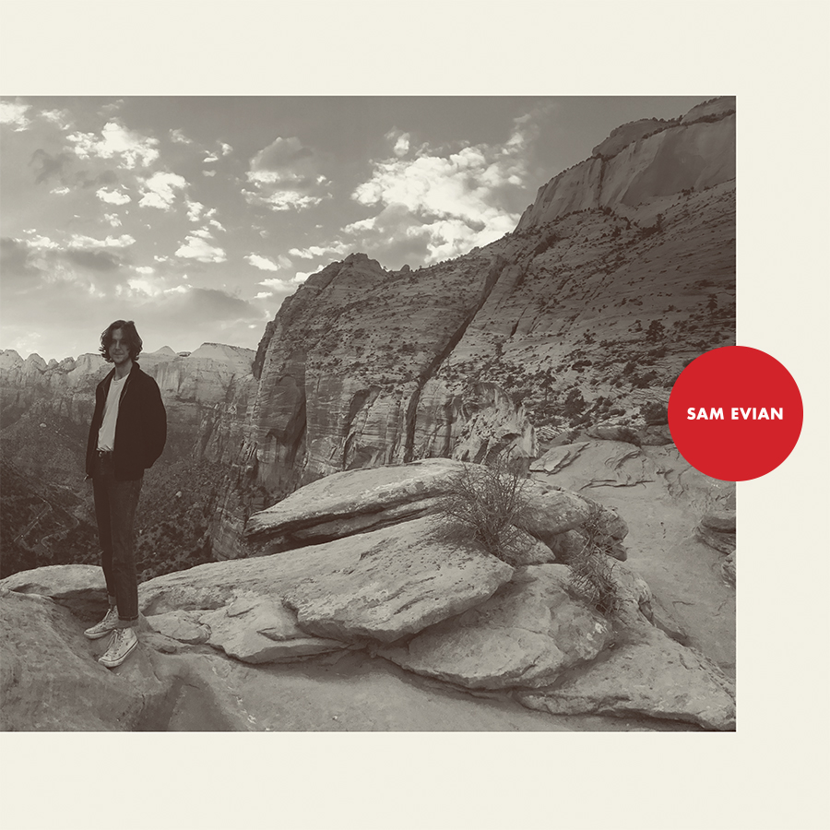
(You, Forever album art)

Official Website | Facebook | Twitter | Instagram | Saddle Creek
For more information, contact:
Jessica Linker & Stephanie Bauman| Pitch Perfect PR - jessica@pitchperfectpr.com, stephanie@pitchperfectpr.com, 773-271-6844

