For Immediate Release February 26, 2018

JOAN BAEZ ANNOUNCES FINAL FORMAL NORTH AMERICAN TOUR

WHISTLE DOWN THE WIND OUT MARCH 2
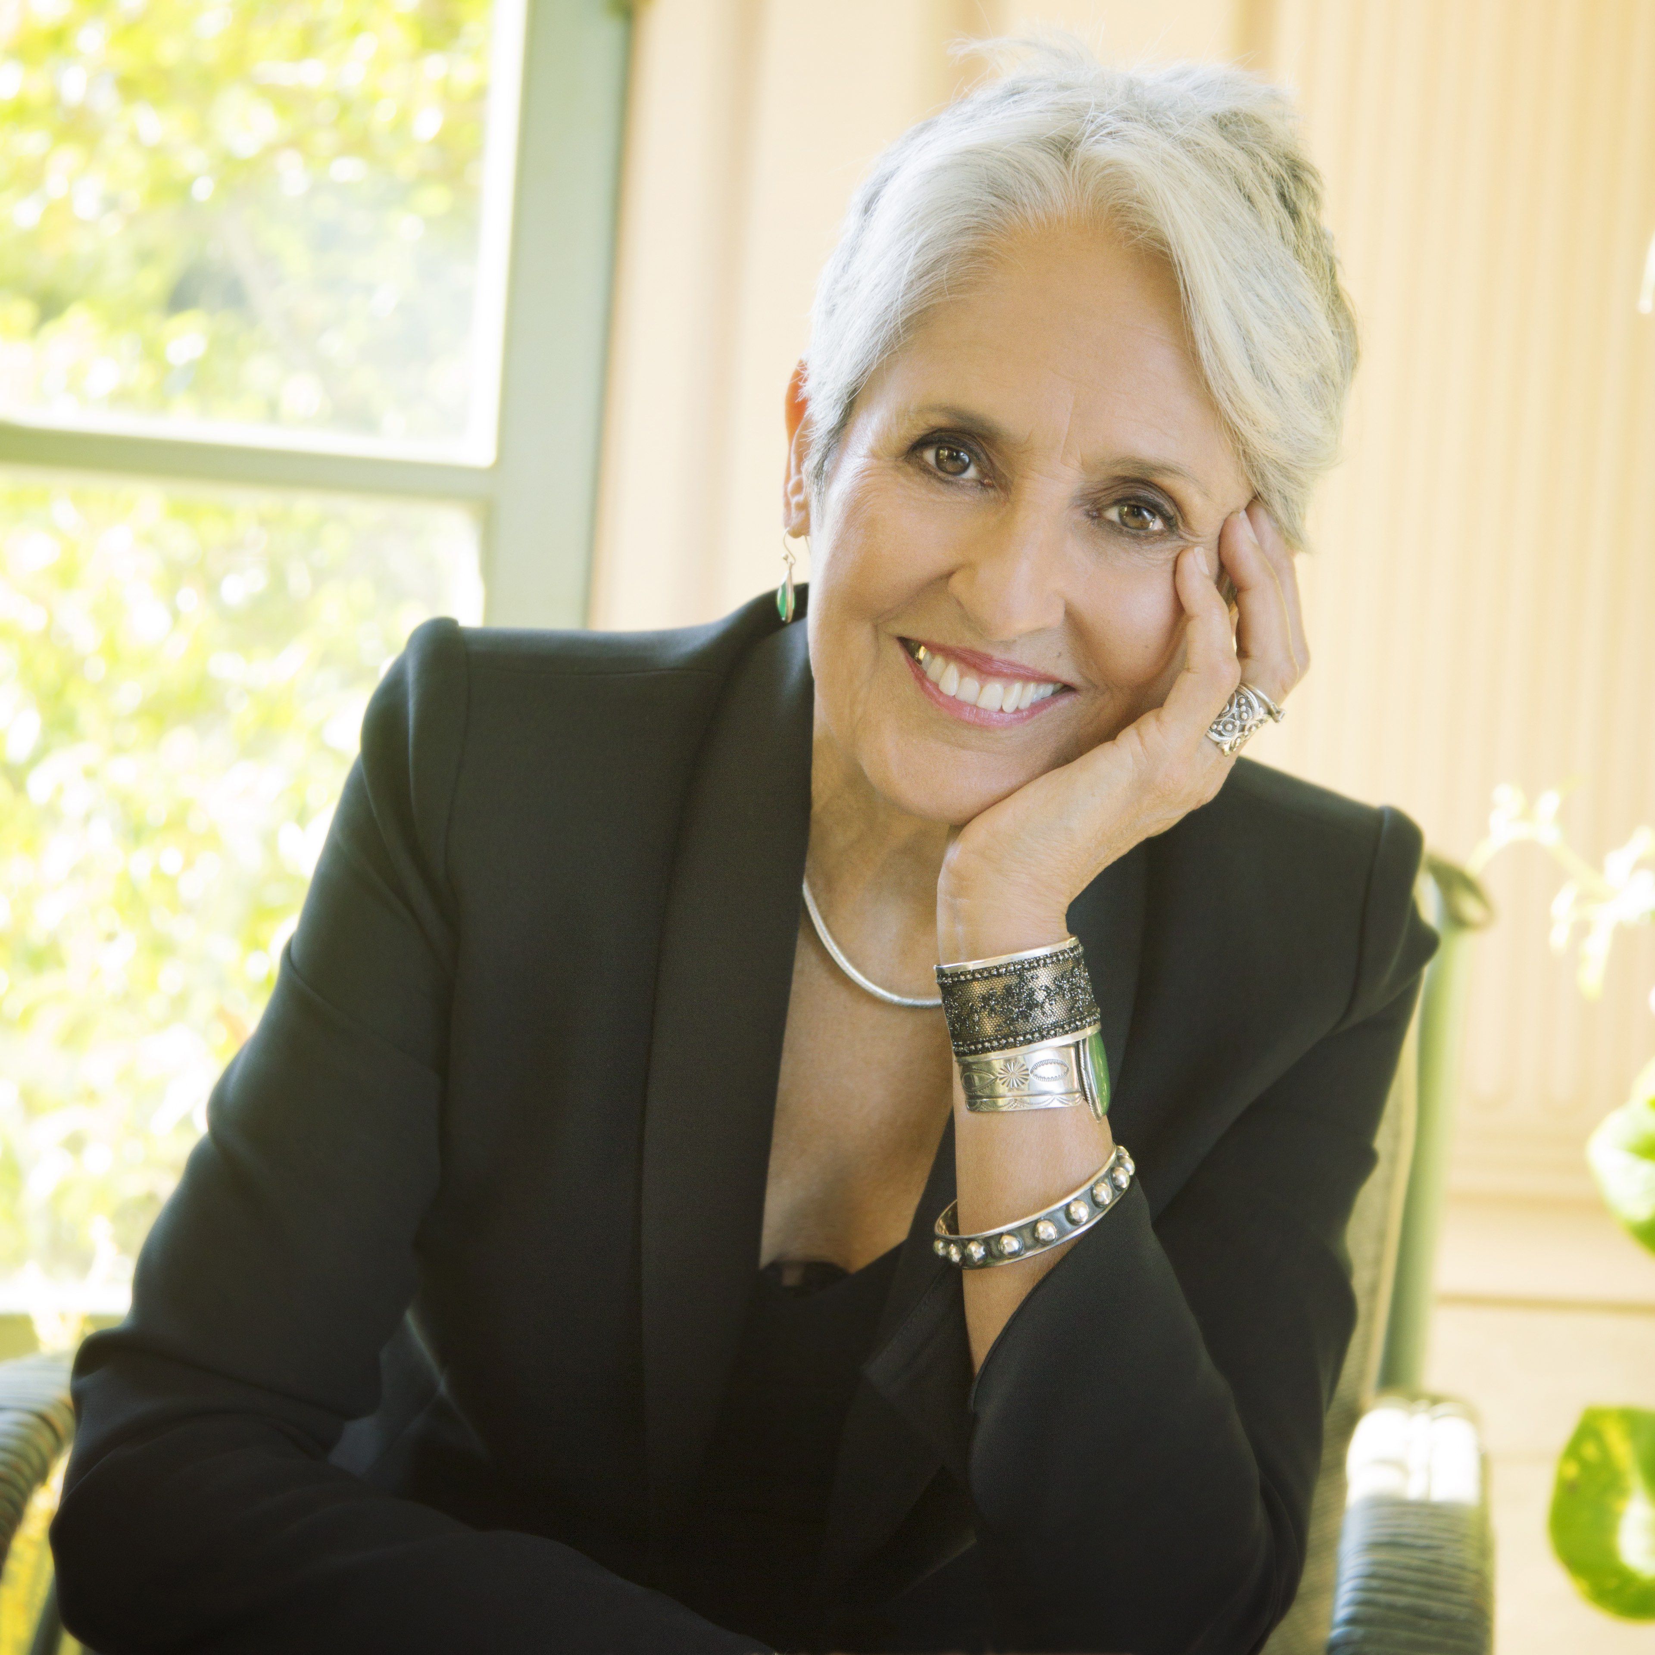
Acclaimed artist and activist Joan Baez will begin a run of North American dates beginning on September 11 in Ithaca, NY. The extensive run of shows, following 50 UK and European dates, marks Baez’s last year of formal touring and includes stops at the historic Beacon Theatre in New York City and Ryman Auditorium in Nashville. See below for complete tour details.
“I’m looking forward to being on the road with a beautiful new album of which I am truly proud,” says Baez. “I welcome the opportunity to share this new music as well as longtime favorites with my audiences around the world.”
As a special offer to fans purchasing tickets for Baez’s U.S. tour, a CD or digital download of her forthcoming album, Whistle Down The Wind, is included with every ticket purchased. Tickets for all shows go on sale March 2 (For details on pre-sales and other ticketing details, please visit venue websites).
Whistle Down The Wind is out on March 2 via Bobolink/Razor & Tie Records and is available for pre-order at http://amzn.to/2Evvavx. The record, which is exclusively streaming now via NPR Music, is receiving early critical praise—NPR Music proclaims, “This particular batch of folk songs amplifies Baez ever-present gift for interpretation” while Rolling Stone calls it, “A moving reflection and summation of Baez’s life as a singer, musician and activist.”
Recorded over a ten-day period in L.A., Whistle Down The Wind was produced by 3-time Grammy Award-winner Joe Henry (Bonnie Raitt, Allen Toussaint and others) and includes songs written by Tom Waits, Anohni, Mary Chapin Carpenter, Josh Ritter, Eliza Gilkyson and more. Of working with Henry, Baez comments, “It was a hunch on both of our parts that we could make an album together. As it turned out it was a no brainer. We both work fast and were musically on the same wavelength. I work best with musicians who are as willing as I am to wing it and he assembled a group of players who did just that. Meaning invent each song from scratch.”
The new music marks the first release from Baez since 2008’s Grammy-nominated album, Day After Tomorrow. Its release, which ignited an extraordinary decade of achievement for Baez, coincided with the 50th anniversary of her legendary 1958 residency at the famed Club 47 in Cambridge. Milestones over the past ten years include:
- 2009: PBS American Masters premiere of her life story, Joan Baez: How Sweet The Sound, which underscored the 50th anniversary of Baez’s debut at the 1959 Newport Folk Festival.
- 2011: Baez’ seminal debut album of 1960 honored by the National Academy of Recording Arts & Sciences in 2011, which inducted it into the Grammy Hall Of Fame.
- 2015: Library of Congress selects Baez’s debut album to be preserved in the National Recording Registry.
- 2015: Amnesty International bestowed its highest honor on Baez, the Ambassador of Conscience Award, in recognition of her exceptional leadership in the fight for human rights.
- 2016: Baez’s 75th birthday was celebrated at New York’s Beacon Theater in January, where Paul Simon, Jackson Browne, Emmylou Harris and others joined her. The concert premiered on the PBS Great Performances series in May 2017.
- 2017: Rock & Roll Hall Of Fame induction
- 2017: Baez’s first solo exhibition of paintings, entitled “Mischief Makers,” was presented in Mill Valley, CA. The entire exhibit was subsequently purchased by the Federated Indians of Graton Rancheria and donated to Sonoma State University, where it will eventually be displayed at an envisioned new social justice-learning center on campus.
Baez remains a musical force of incalculable influence. She marched on the front line of the civil rights movement with Martin Luther King, Jr., shined a spotlight on the Free Speech Movement, took to the fields with Cesar Chavez, organized resistance to the Vietnam War, inspired Vaclav Havel in his fight for a Czech Republic, saluted the Dixie Chicks for their courage to protest the Iraq war, stood with old friend Nelson Mandela in London’s Hyde Park as the world celebrated his 90th birthday and, most recently, protested the construction of the Dakota Access Pipeline at Standing Rock Sioux Reservation. To this day, she continues to stand passionately on behalf of causes she embraces.
WHISTLE DOWN THE WIND TRACK LIST
1. Whistle Down The Wind (Tom Waits and Kathleen Brennan)
2. Be Of Good Heart (Josh Ritter)
3. Another World (Anohni)
4. Civil War (Joe Henry)
5. The Things We Are Made Of (Mary Chapin Carpenter)
6. The President Sang Amazing Grace (Zoe Mulford)
7. Last Leaf (Tom Waits and Kathleen Brennan)
8. Silver Blade (Josh Ritter)
9. The Great Correction (Eliza Gilkyson)
10. I Wish The Wars Were All Over (Tim Eriksen)

JOAN BAEZ LIVE
September 11—Ithaca, NY—State Theatre
September 12—New Haven, CT—Shubert Theater
September 14 & 15—Boston, MA—The Wang Theatre
September 17—Montreal, QC—Place Des Arts Maison Symphonique
September 18—Toronto, ON—Roy Thomson Hall
September 21 & 22—New York, NY—Beacon Theatre
September 25—Red Bank, NJ—Count Basie Theatre
September 26—Philadelphia, PA—Verizon Hall @ Kimmel Center for the Performing
September 28—Washington, DC—Warner Theatre
September 29—Durham, NC—Durham Performing Arts Center
September 30—Nashville, TN—Ryman Auditorium
October 2—Ann Arbor, MI—Michigan Theater
October 3—Cleveland, OH—State Theatre
October 5—Chicago, IL—Chicago Theatre
October 6—Minneapolis, MN—State Theatre
October 24—Denver, CO—Paramount Theatre
October 25—Santa Fe, NM—The Lensic Performing Arts Center
October 27—Phoenix, AZ—Celebrity Theatre
October 28—Tucson, AZ—Fox Tucson Theatre
October 30—San Diego, CA—Humphreys Concerts
November 4—Seattle, WA—Benaroya Hall
November 5—Portland, OR—Revolution Hall
November 8—Eureka, CA—Arkely Center for the Performing Arts
November 10—Los Angeles, CA—Royce Hall
November 15—San Francisco, CA—The Masonic
November 17—Oakland, CA—Fox Theater Oakland
For more information, please contact Asha Goodman 615.320.7753,
Louis D’Adamio or Carla Sacks 212.741.1000 at Sacks & Co., asha.goodman@sacksco.com, louis.dadamio@sacksco.com or carla@sacksco.com.

