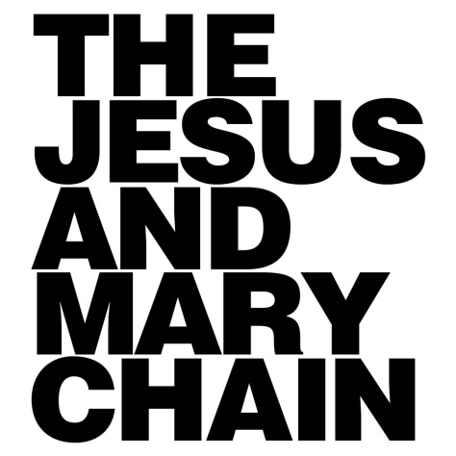
SHARE NEW VERSION OF ‘THE TWO OF US’
FEATURING SKY FERREIRA

LISTEN HERE

“A wondrous return to form for a band born in melancholy.” – Pitchfork

“The Jesus & Mary Chain are forever kings of cool.” – Vice

“An unforeseeable triumph.” – Mojo

“‘Damage and Joy’ underscores the Mary Chain’s key strengths… bold guitar riffs and the pneumatic whirl of drum machines are the order of the day.” – Uncut

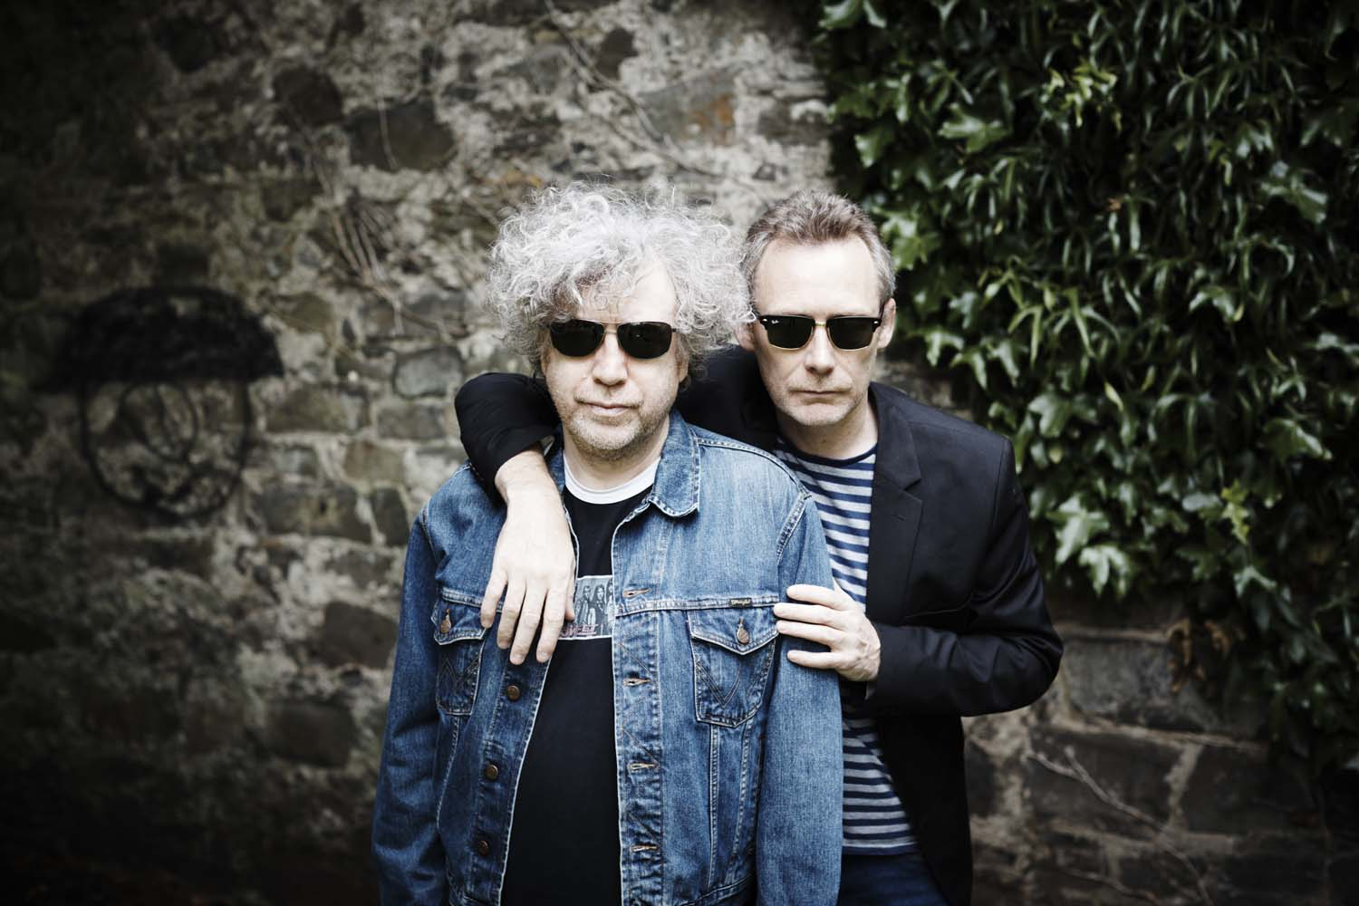

After a nineteen-year absence from recording, The Jesus And Mary Chain returned with ‘Damage And Joy’ which hit the Top 20 and immediately became their highest charting album since ‘Stoned & Dethroned’ back in 1994. The phenomenal reaction has been as if they’ve never been away: they’ve toured the UK and the US, sold-out London’s Shepherds Bush Empire and hit Stephen Colbert’s Late Show to perform ‘The Two Of Us’ with Sky Ferreira.

Although the album version of the ‘The Two Of Us’ featured Isobel Campbell, The Jesus And Mary Chain have again teamed up with Sky Ferreira to record a fresh new version of the track. Jim Reid’s coolly understated delivery contrasts with Ferreira’s impassioned vocal, while William Reid’s distorted riffs add rock ‘n’ roll grit to the Sixties-tinged track.

The Jesus And Mary Chain continue their touring in support of ‘Damage And Joy’ with a fresh blast of touring with shows in the USA and Canada

October 19 – San Francisco, CA @ The Fillmore
October 21 – Los Angeles, CA @ Cloak and Dagger Fest
October 22 – Sacramento @ Ace of Spades
October 24 – Eugene, OR @ The McDonald Theater
October 25 – Portland, OR @ Crystal Ballroom
October 26 - Spokane, WA @ The Bing Crosby Theater
October 28 - Calgary, Alberta @ MacEwan Ballroom
October 29 - Edmonton, AB @ Jubilee Auditorium
October 31 – Missoula, MT @ The Wilma
November 2 – Salt Lake City, UT @ The Complex
November 3 – Denver, CO @ The Fillmore
November 5 – Dallas, TX @ Bomb Factory
November 7 – Austin, TX @ Emo’s
November 8 – Houston, TX @ White Oak Music Hall
November 10 - Memphis, TN @ The New Daisy Theatre
November 11 - Louisville, KY @ Headliners
November 12 - Atlanta, GA @ The Variety
November 14 - Baltimore, MD @ Ram’s Head Live
November 15 - Boston, MA @ Paradise
November 16 - Asbury Park, NJ @ The Stone Pony
November 17 - NY NY - Playstation Theater

Ticket info at http://thejesusandmarychain.uk.com/live

http://thejesusandmarychain.uk.com/
https://twitter.com/TheMaryChain
https://www.facebook.com/JesusAndMaryChain/
https://open.spotify.com/artist/4rjlerN21ygkIhmUv55irs

