The Pioneer Latin-American Folk-Rock Group
BIOGRAPHY

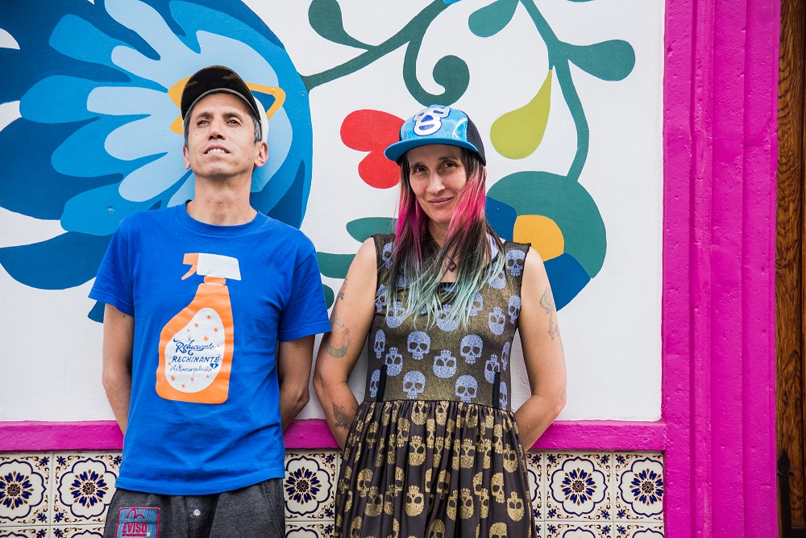
Aterciopelados, the pioneer Latin-American folk-rock group, returns after 8 years with their first long and live project entitled "Reluciente, Rechinante y Aterciopelado." This CD+DVD is a compilation of the most representative songs of their repertoire that celebrates over two decades of their existence as a band. It features the participation of big names, such as Macaco, León Larregui (vocals for the Mexican group Zoé), Goyo (Chocquibtown) and Catalina García (Monsieur Periné).
The group's members, Andrea Echeverri and Héctor Buitrago, founded Aterciopelados in 1992 and achieved great success, both locally and internationally, thanks to a sound that was absolutely unique and innovative, free of prejudices, mixing rock with the roots of Colombian folklore and even with salsa and bossa nova.
Aterciopelados have grown and evolved with each production, making history in Latin America and the rest of the world. They have released seven studio and one compilation album, selling over ten million copies of their records. Their album Río has been mentioned by Rolling Stone magazine as one of the 10 best Latin rock albums of all times.
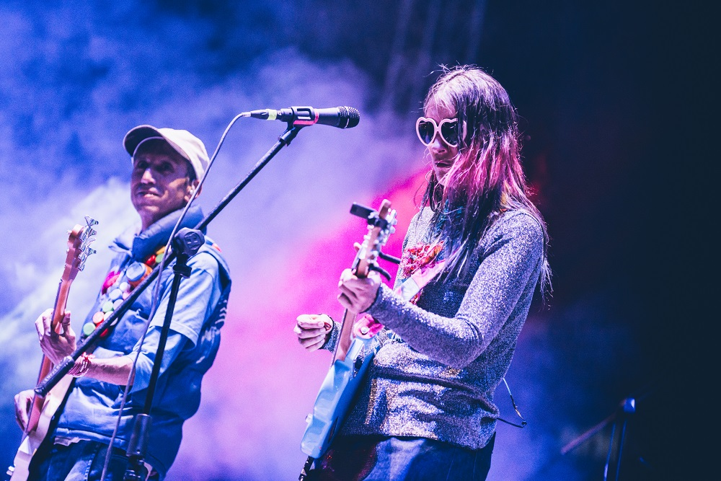
They have earned two Latin Grammy awards and been nominated on multiple occasions for the Grammy. Aterciopelados are also Amnesty International ambassadors focusing on the fight against abuse of women and have been strong activists since the beginning of their journey as a group, as well as individually, with Andrea releasing three studio recordings ("Andrea Echeverri", "Dos" & "Ruiseñora") that reveal a very clear position regarding gender issues and the rights of women. The first one of said albums carries her name.
Furthermore, Hector, who is composer and producer for many up and coming artists, has always been interested in the environment and the legacy from ancestral indigenous people, and has actively participated in organizing "Canto al Agua," an intercultural network focusing on healing and caring for the water. His soloist discography consists of his albums "Conector", "Conector II" and "Niños Cristal".
Hector and Andrea are currently presenting "Reluciente, Rechinante y Aterciopelado", homage to all the songs that turned them into one of the greatest and most renowned rock bands in Colombia and worldwide. As a result of their getting together after a three-year recess and with the objective of presenting their greatest hits at the 20 years of Rock al Parque, they have created this CD+DVD. It includes songs that made the "50 most viral songs of Colombia"
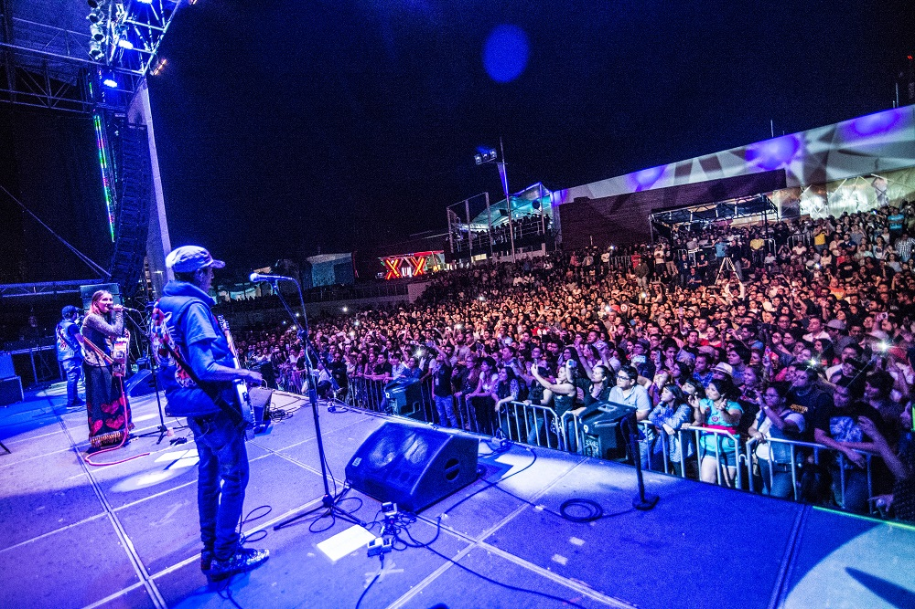

This is an album filled with environmental-friendly elements, and all related videos of the group are already available on the Vevo channel on Youtube and available on all streaming and online purchasing websites. It is a summary of the greatest hits of a legendary band that has left its imprint on more than one generation for over two decades.

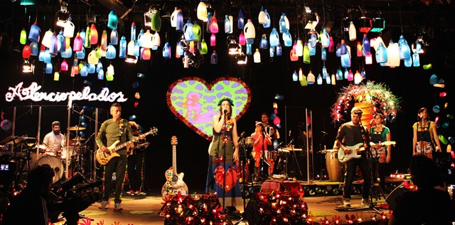
In the middle of their world tour “Reluciente, Rechinante 2017”, in which they support the release of the live album that bears this name in different countries in Europe, Aterciopelados’ pays tribute to Juan Gabriel, with its version of “He venido a pedirte Perdón”.
According to Andrea and Héctor, this song is "Sound nu disco and plancha futurista", referring to the term 'iron music' that in Colombia encompasses the great songwriters of Latin music of the 70’s and 80’s.

DISCOGRAPHY
Reluciente, Rechinante &Aterciopelado Río 2008
2016
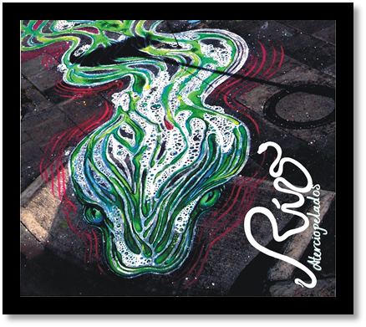
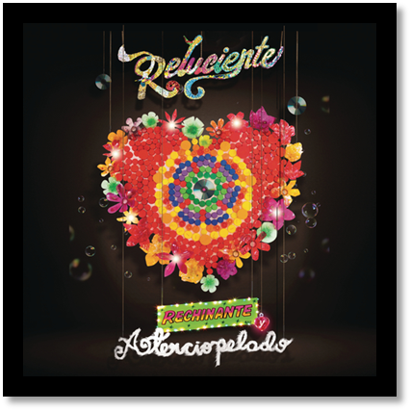

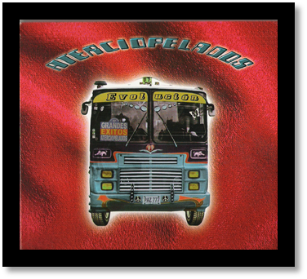
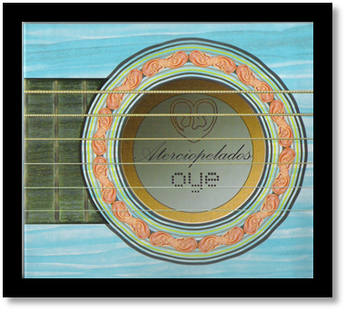
Oye - 2006 Evolución - 2002

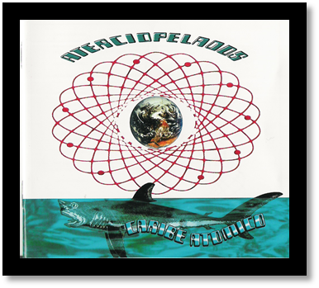
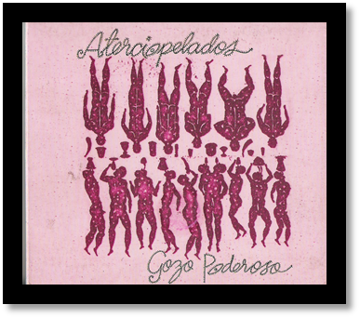
* Gozo Poderoso - 2000 Caribe Atómico - 1998

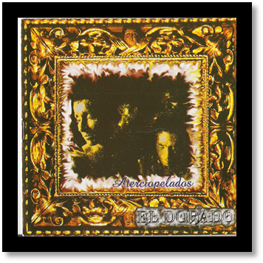
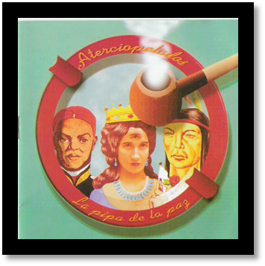
* La Pipa de la Paz – 1996 * El Dorado - 1994

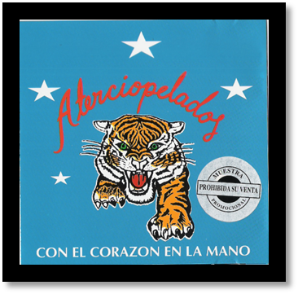

* Con el Corazón en la
Mano 1993

