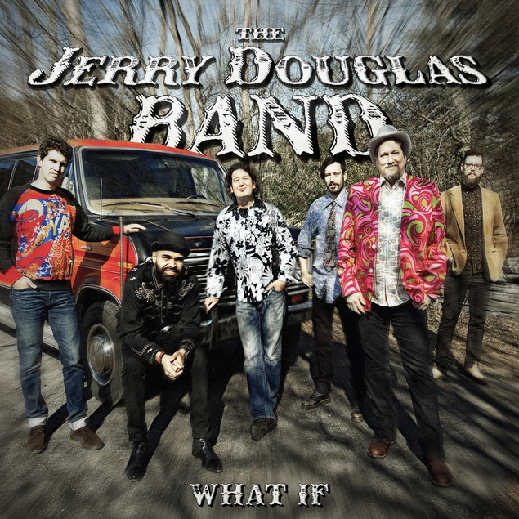
The Jerry Douglas Band
What If
August 18, 2017

Jerry Douglas was a teenager playing in a band in Lexington, Kentucky, the first time he heard Weather Report and Chick Corea — on the same day. More than 40 years later, he remembers the moment vividly.

“It blew my head off,” he says. “I loved it. And I thought, ‘Well, there’s where I could go with all this stuff runnin’ around in my head.’”

“All this stuff” is the remarkable music Douglas has made on Dobro and lap steel in a career that’s earned him world renown as the top purveyor of his craft. On his latest musical foray, What If, Douglas decisively merges those jazz inclinations with the bluegrass, country, blues, swing, rock, and soul he’s spent his life absorbing and performing, forging a sound that flies beyond the boundaries of anything he — or anyone else — has done before.

Though Douglas has recorded several of these songs previously, he turns them inside out here in bold new arrangements filled with unexpected elements. For example, in 1992 he covered “Hey Joe,” the Billy Roberts folk tune that became one of Jimi Hendrix’s most beloved blues-rockers, as an uptempo bluegrass song. Here, it’s recontextualized again with drums and fiddle — and horns instead of mandolin. And “Freemantle,” which Douglas and banjoist Béla Fleck had co-written and recorded decades ago as a duet, is now so deeply layered, it almost begs to be heard through headphones.

Like fellow bluegrass-rooted peers Fleck and David Grisman, Douglas has always balanced respect for tradition with a desire to escape constricting expectations. But there were places even he was afraid to go — until now.

“I’ve always heard horn lines in my songs, and I usually put something else there instead,” he explains. But after bassist Daniel Kimbro joined the Jerry Douglas Band in 2013, he introduced Douglas to guitarist Mike Seal, trumpet player Vance Thompson, and saxophonist Jamel Mitchell — a nephew of famed Al Green producer Willie Mitchell and son of James, one of the original Memphis Horns players.

“They opened a door that I had hesitated to pass through before,” Douglas admits. It led to a place where he felt free to follow those previously stifled leanings. “I thought, ‘OK, I’m just gonna write like there are really gonna be horns this time, so I’ll just go ahead and stretch it on out,’ instead of thinking, ‘Well, I won’t have real horns ’cause I’ll piss somebody off.’ I’m over that.”

“A lot of what you do as a musician comes from fear; what you think the audience will stand,” he says. “But I think they’re with me at this point. Audiences are more broadminded than they were when I started playing.”

Truthfully, though, audiences have been with him since he started performing in his early teens. Born in Warren, Ohio, Douglas was 8 when his bluegrass-loving dad took him to hear Lester Flatt and Earl Scruggs. Douglas fell in love with the sound he heard coming from Josh Graves’ Dobro. Five years later, he was playing Ohio’s finest dives in his dad’s band, entertaining southern-born steel workers (and sipping vodka drinks the little-old-lady bartenders made him). He spent much of his time listening to bluegrass, though proximity to the rock bastion of Cleveland helped foster his awareness of the Beatles, Stones, Byrds, and other top acts of the day.

As soon as he graduated from high school, Douglas headed to Washington, D.C., to join Charlie Waller, Ricky Skaggs, and Doyle Lawson in the Country Gentlemen. He’s since performed in so many incarnations, at one point, he counted membership in eight bands — simultaneously. His recent history includes his band the Earls of Leicester (pronounced “Lester”; get it?), - his version of the Flatt and Scruggs band - with Shawn Camp, Charlie Cushman, Jeff White, Johnny Warren, and Barry Bales; their self-titled 2014 debut earned Douglas his 14th Grammy. He’d already picked up eight with Alison Krauss & Union Station, with whom he’s closing out his second decade, and shared the Album of the Year win for O Brother, Where Art Thou?, the film soundtrack that helped replant traditional roots music in the modern American psyche.

Douglas took home his first golden gramophone in 1983 as a member of J.D. Crowe’s New South, with Skaggs and Tony Rice — though it was their self-titled 1975 album that was said to change the course of bluegrass and become a landmark of the genre.

It was Skaggs who nicknamed Douglas “Flux” — which reportedly has more to do with his fluid, flowing finger work than his shifting musical identities. Though come to think of it, his music does tend to shift stylistically as often as the configurations in which it’s delivered — which have also included the newgrass-influenced Strength in Numbers (with Fleck, Sam Bush, Edgar Meyer, and Mark O’Connor), and Elvis Costello’s all-over-the-map Sugarcanes (with Jim Lauderdale, Stuart Duncan, Dennis Crouch, Mike Compton, and Jeff Taylor).

In 1998, Douglas joined fiddler Aly Bain as co-music director for the BBCScotland-TV show Transatlantic Sessions, in which U.K., Irish, and North American artists gather in Scottish manors or similar locales to make music. This year, they embarked on their first stateside tour, featuring guests including Rosanne Cash, James Taylor, Sarah Jarosz, John Paul White, Aoife O’Donovan, the Milk Carton Kids, and Mary Chapin Carpenter.

He also somehow finds time to perform solo, as well as produce and do session work for other artists. Living in Nashville since 1979, he’d actually left the road for 15 years, after a string of ’80s hits with the Whites, to concentrate on studio work. “I was doin’ so much of it,” Douglas recalls, “every time I left town, I lost money.”

Though he’s still racking up recording credits — the tally is now over 2,000, according to his website, and may be Guinness Book-worthy — Krauss, he says, “rescued me.” In the ensuing years, he often pondered, “What if?” Finally, that became What If.

“It’s been a long time comin’,” Douglas says. “I promised my dad I would make a bluegrass record, so I made two Earls of Leicester records. He should be satisfied now. I hit my quota.”

And then some. But this album wasn’t a sure thing until Douglas heard the band perform the Edgar Meyer composition “Unfolding.” He’d played with Fleck, Bush and O’Connor on Meyer’s original 1986 version, then covered it on his 2008 album, Glide.

“It was way ahead of its time when we recorded it for him,” Douglas says. “We didn’t know how to play music like that, most of us. Though I cut it on my own, that’s another one I wanted to revisit. … When this band played that song, it let me know there was really something to this — that it had a future.”

On this elegant track, Dobro gives way to fiddle, then sax, then bass; each virtuosic solo simply seems to … unfold.

That’s what What If did, too. Douglas says he initially planned to record the band’s performing set list, then realized he had unheard material these players could tackle. In some cases, their input radically changed the song.

“I’d come up with the tune, and they would help me take it to some crazy places,” he says. Not coincidentally, What If marks the recorded debut of the Jerry Douglas Band — because, according to Douglas, it’s a real band effort (also including longtime drummer Doug Belote and violinist Christian Sedelmyer, who joined in 2014).

Guitarist Seal had particularly heavy involvement in “Battle Stick,” a song with multiple time signatures, flipped-backward instrumentation, and other Beatles-influenced “tricks” Douglas loves using.

“There’s a part in the middle where we kind of lay the melody on its side, like something Sting would do. It completely changes the whole feel,” he notes.

Speaking of changing the feel, Douglas’ rendering of Tom Waits’ “2:19” is a funky revelation, dripping with soul — and vocals that sound like they’re rolling from the lips of a grizzled Beale Street bluesman killing it at 3 a.m., not a three-time Country Music Association Musician of the Year. (Douglas’ incredibly long list of accolades also includes winning a National Endowment for the Arts National Heritage Fellowship and an Americana Music Association Lifetime Achievement Award.)

He also radically reconfigures the album opener “Cave Bop,” originally recorded in 2002. This time, it contains the horns he always wanted it to have.

“The first time I recorded it, we just played it as fast as we possibly could. This time, we made it a bit more sophisticated, with more of an arrangement,” he says. “A lot of times, when you record songs, you don’t really know ’em yet. I got another shot at this one.”

He likes to describe the tune as “a Flintstones rumble, with Fred in the driver’s seat and Charlie Parker as his passenger.

“The two should never show up in the same sentence!” he adds, laughing. But in this unlikely fusion of “bebop jazz and caveman jazz,” they somehow ride together perfectly — adding some swing as they speed toward “Birdland.”

On an album containing one marvel after another, the title tune, with its symphonic sweep, might be the ultimate definition of a mindblower. What started out as an exercise “just to get my hands talking to each other” turns into an understated, yet dramatic sonic experience.

“It’s almost a magic trick to play what I’m playing underneath the melodies,” Douglas says. “It’s all wrong for the count; really against the grain. You kind of have to find a spot on the floor and stare at it to take your mind off what you’re doing, because if you think about it too much, you’ll go completely out of time and just turn it upside down. It’s like a Rubik’s Cube, this song is.”

It might be tricky to play, but for listeners, the operative word — for the whole album — is magic.

