Cymbals Eat Guitars

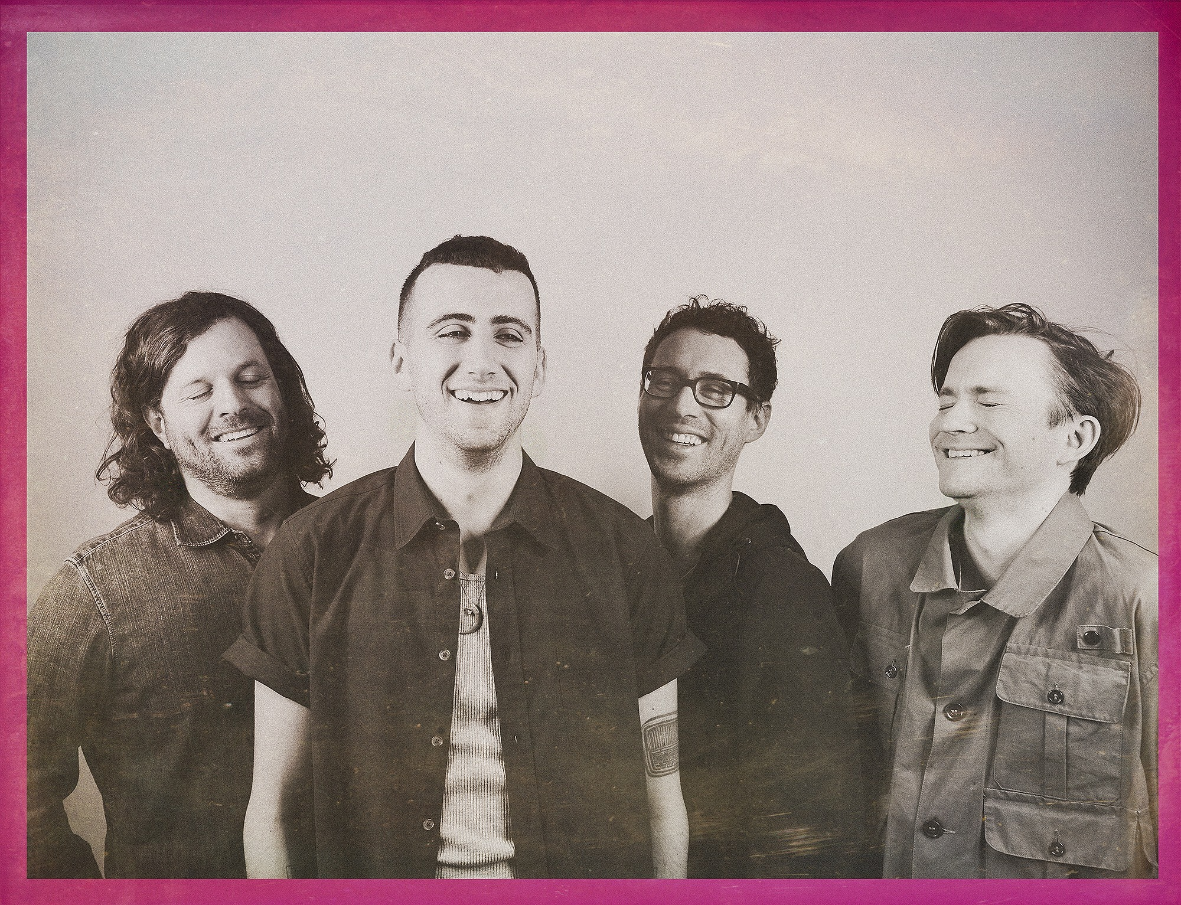
Photo Credit: Shervin Lainez

Download/stream the new album Pretty Years

Cymbals Eat Guitars have indeed crafted what’s easily their most sonically expansive and most rewarding album to date with their John Congleton produced fourth LP, Pretty Years on Sinderlyn Records. Their trademark cacophonic guitar rock and innate propulsion are still abundant, but they’re buttressed by raucous synth and keyboard lines, and an extemporaneous saxophone performance, which enrich when they could easily clutter these songs. The band also worked more quickly and efficiently than they had in the past, facilitated by years on the road in which they’ve played close to a thousand shows, which rendered them a tight, fully- oiled machine in the studio.

“Cymbals Eat Guitars are still making the best music of their careers” – Pitchfork

“Joyous, revelatory…[Pretty Years is] the band’s best album.” A- review – AV CLUB

“[Cymbals Eat Guitars] have made one of the best classic-rock records of the 21st century.” – Spin Magazine

“[Cymbals Eat Guitars] are at the peak of their powers, and every song they record is worthy of your attention.” – USA Today

PRETTY YEARS PRESS
- Pretty Years’ earns 8.0 review - Pitchfork
- Cymbals Eat Guitars and the Beauty of Patience - Noisey
- “raucous-yet-refined rock” - NPR
- “there’s something about vocalist Joe D’Agostino’s overstuffed vocal climaxes and Mascis-ian guitar squeals that fills up small venues with huge, trembling splinters of emotion and sound.” - Consequence of Sound
- “If Springsteen were making music in an East Williamsburg flophouse, it might sound a lot like this wonderfully stoner-rock anthem [‘Finally’] from the Staten Island-bred indie stalwarts” – Entertainment Weekly
- “a remarkably intimate and affecting collection of stories, with an expanded sonic palette that finds Cymbals Eat Guitars continuing their journey as one of the best rock acts around.” London in Stereo

ADDITIONAL HIGHLIGHTS
- Video for “4th of July, Philadelphia (Sandy)”, released June 2016, directed by Field Mouse’s Rachel Browne
- National US Headlining Tour in Fall 2016. Expansive European Tour February 2017. Tour Dates
- Previously toured with Brand New, Bob Mould, This Will Destroy You, and Alex G amongst others
- Signed to Sinderlyn, new label founded by Captured Tracks’ Mike Sniper

***
Management: Mike Martinovich: mike.martinovich@redlightmanagement.com | olivia.harrington@redlightmanagemt.com
Four Touring/Support Outreach Please Contact: olivia.harrington@redlightmanagement.com | eric.mayers@redlightmanagement.com
Digital Inquiries: jay.barnings@redlightmanagement.com

Label: Sinderlyn: Mike Sniper: mike@capturedtracks.com | Pam Garavano-Coolbaugh: pam@capturedtracks.com | Dave Martin: dave.martin@omnianmusicgroup.com
US Publicist: Kip Kouri: kip@tellallyourfriendspr.com
US Booking Agent: Frank Riley: frank@highroadtouring.com || UK Booking Agent: Paul Boswell: paulb@freetradeagency.co.uk
2017 European Tour Dates

*****

Tuesday February 7: Edinburgh, UK @ Electric Circus

Wednesday February 8: Manchester, UK @ Soup Kitchen

Friday February 10: London, UK @ the underworld camden

Saturday February 11: Bruges, Belgium @ Cactus Club

Sunday February 12: Cologne, Germany @ Studio 672

Monday February 13: Berlin, Germany @ Badehaus Szimpla

Wednesday February 15: Stockholm, Sweden @ Kagelbanen

Thursday February 16: Oslo, Norway @ Blå

Friday February 17: København @ Stengade

Saturday February 18: Hamburg, Germany @ Nochtspeicher

Monday February 20: Amsterdam, Netherlands @ Paradiso

Tuesday February 21: Paris, FR @ Point Ephémére

Wednesday February 22: Zurich, Switzerland @ Rote Fabrik

Thursday February 23: Milan, Italy @ Circolo Magnolia

Saturday February 25: Bologna, Italy @ Covo Club

Monday February 27: Bezirk-Landstrasse, Austria @ Arena Wien

Tuesday February 28: Praha, Czech Republic @ Klub 007 Strahov

Thursday March 2: Brussels, Belgium @ Rotonde – Botanique

*****

