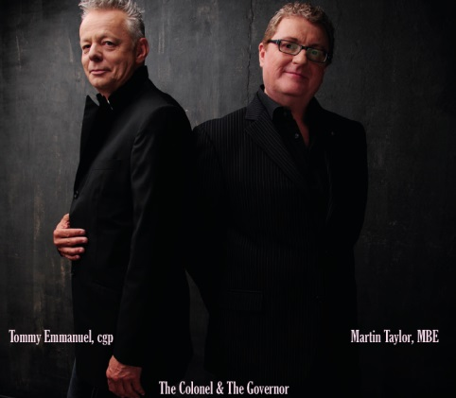
THE COLONEL & THE GOVERNOR REVIEWS

"The Colonel whips up standards, pop songs and originals by way of conviviality... [it's] just stringed, fretted fun."
Jazz Times

“Aficionados of the style out there will love it…the guitar work is mesmerizing.”
No Depression

“It’s as if they were always destined to work together.”
The Birmingham Mail

“Tommy Emmanuel's steel-string fretwork is technically dazzling and atmospheric.”
Chicago Tribune
“Blessed with impeccable taste and exceptional technique, [Tommy Emmanuel is] able to perform folk, rock, jazz, country and blues with fluid ease and impressive authority.”
San Diego Union Tribune

LIVE AND SOLO IN PENSACOLA, FLORIDA REVIEWS

“He shreds like Yngwie Malmsteen, plays with symphonic finesse worthy of an opera hall, and performs a slapstick number straight out of Disney’s Country Bear Jamboree handbook with equal aplomb.”
Music News Nashville

“Having long been known as an incredible live showman this often unheralded legend clearly lays down a legitimate claim to perhaps the finest "fingerstyle" guitarist over the last forty years.”
Critical Jazz

“Tommy Emmanuel is an amazing guitarist. This is evidenced on his many studio recordings. It becomes profoundly obvious when one has the privilege of watching this man perform live and in person”
Boomerocity

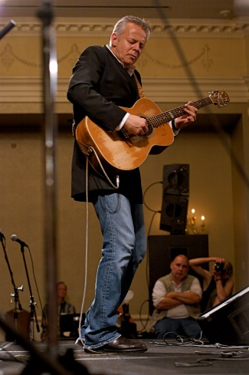
LIVE REVIEWS

“His guitar playing is a lot like his laughter, both of which come easy. Tommy Emmanuel is an instinctive performer, his repertoire untutored and emotive, a product of intuition, not training. His relationship with his instrument of choice results in a sound akin to a conversation between old friends”
Las Vegas Review-Journal

“His Australian charm, his wicked sense of humor, and his quirky washing machine moves had truly won me over. If you have never seen this man perform in person or heard any of his songs look him up now. He truly is amazing.”
BeatWeek

“If you closed your eyes during the Tommy Emmanuel concert Sunday night in DeVos Performance Hall, you’d think that the multiplicity of sounds were coming from all over the auditorium… Emmanuel continues to amaze even listeners who think they know their way around the guitar.”
The Grand Rapids Press

“All the YouTube videos in the world don't do justice to the Australian player whose guitar roared, cooed, hissed and sang for a rapt audience at the Crouse Hinds Theater Tuesday night…With six strings, ten fingers and a whole lot of tricks, Emmanuel directs an orchestra of sound -- one man exploring the bounds of what a single instrument can do.”
The Post-Standard

“There aren’t many artists with the ability to hold an audience in a one man show, but Tommy Emmanuel isn’t an ordinary artist. This was more than a man and his instrument in front of an audience; this was a master of his craft sharing an evening with friends. There were just as many smiles coming from the artist on the stage as there were directed at him. It was difficult to tell who enjoyed the evening more, the guitarist or his audience…and isn’t that really how it should be?”
Guitar International

