March 28, 2017
For Immediate Release

SLOWDIVE ANNOUNCE SLOWDIVE, FIRST NEW ALBUM IN 22 YEARS,
OUT MAY 5TH VIA DEAD OCEANS

WATCH VIDEO FOR NEW SINGLE, “SUGAR FOR THE PILL”
https://www.youtube.com/watch?v=BxwAPBxc0lU

LIVE STREAM SURPRISE LONDON SHOW TOMORROW AT 5:10PM EASTERN

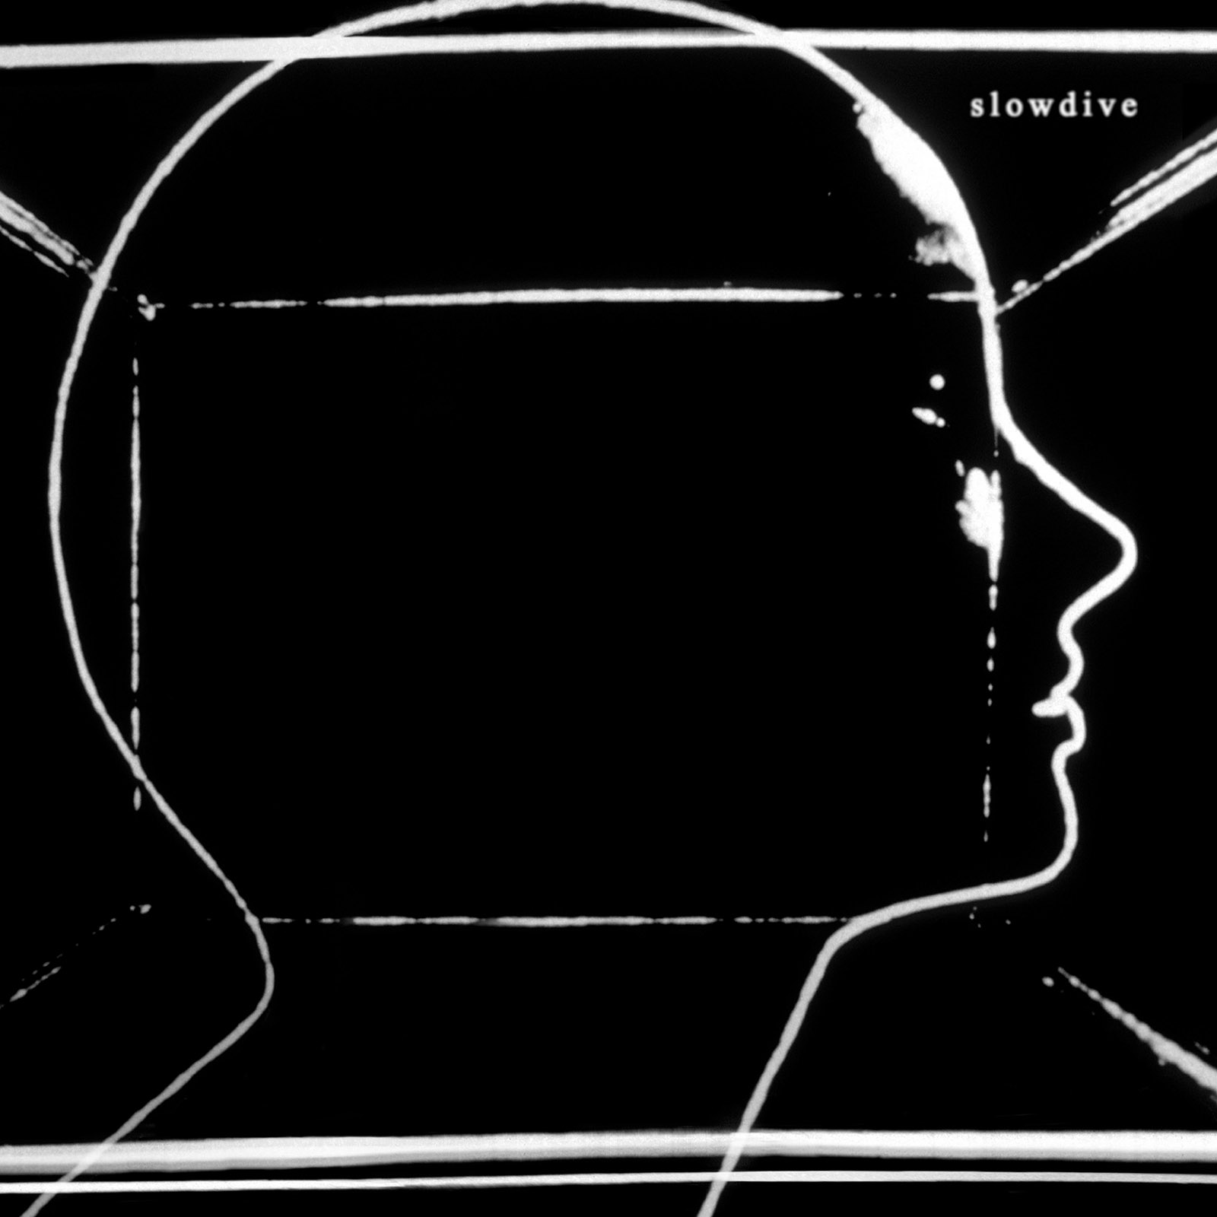

UK shoegaze pioneers Slowdive are pleased to announce their self-titled fourth album, out May 5th via Dead Oceans, and the beautifully understated new single, “Sugar For The Pill,” which follows the release of “Star Roving.” Additionally, Slowdive announce a live stream of a surprise show tomorrow, March 29th, at London’s The Garage, the venue in which the band played their final London show in their original incarnation in December 1993. The stream will go live at 5:10pm Eastern here: facebook.com/slowdive.

Slowdive’s stargazing alchemy is set to further entrance the faithful while beguiling a legion of fresh ears. These eight new tracks, simultaneously expansive and the band’s most direct material to date, deftly swerve away from any “trip down memory lane.” They were birthed at the band’s talismanic Oxfordshire haunt, The Courtyard, and mixed at Los Angeles’ famed Sunset Sound by Chris Coady (Beach House). Throughout, the group dynamic was all-important. “When you’re in a band and you do three records, there’s a continuous flow and a development. For us, that flow re-started with us playing live again and that has continued into the record,” notes principal songwriter Neil Halstead.

The video for “Sugar For The Pill,” produced by in/out, takes its inspiration from the Slowdive album artwork which is itself a still from Harry Smith’s cult classic animation Heaven and Earth Magic - the vast spiritual narrative that has influenced so many artists since it was originally released back in 1957.

Slowdive is Neil Halstead (vocals, guitar, keyboards), Christian Savill (guitar), Nick Chaplin (bass), Rachel Goswell (vocals) and Simon Scott (drums, electronics). Their debut album, Just For A Day, was released in 1991 by Creation Records and was followed by the band’s now revered 1993 album Souvlaki and 1995’s Pygmalion before they disbanded. In the 22 years of their virtual disappearance, compilation albums have been released and the core members of the group have gone on to join other musical endeavours. In 2014, the band announced that they’d reunited and more new music would follow.

Watch Slowdive’s “Sugar For The Pill” Video –
https://www.youtube.com/watch?v=BxwAPBxc0lU

Listen to Slowdive’s “Star Roving” –
https://youtu.be/ogCih4OavoY

Pre-order Slowdive --

Slowdive Tour Dates:
Mon. March 27 – Glasgow, UK @ Art School – SOLD OUT
Tue. March 28 – Liverpool, UK @ Liverpool Arts Club – SOLD OUT
Wed. March 29 – London, UK @ The Garage
Thu. March 30 – Bristol, UK @ The Fleece – SOLD OUT
Fri. March 31 – The Hague, NL @ Rewire Festival
Sun. April 2 – Paris, FR @ Trabendo – SOLD OUT
Mon. April 3 - Berlin, DE @ Festsaal -- SOLD OUT
Sun. April 30 – Fort Worth, TX @ Fortress Festival
Tue. May 2 - St. Paul, MN @ Palace Theatre
Wed. May 3 - Chicago, IL @ Vic Theater # -- SOLD OUT
Fri. May 5 - Toronto, ON @ Danforth Music Hall # -- SOLD OUT
Sat. May 6 – Montreal, QC @ L’Olympia
Sun. May 7 - Washington, DC @ 9:30 Club # -- SOLD OUT
Mon. May 8 - Brooklyn, NY @ Brooklyn Steel # -- SOLD OUT
Tue. May 9 – Brooklyn, NY @ Brooklyn Steel
Wed. May 10 – Carrboro, NC @ Cat’s Cradle
Thu. May 11 – Atlanta, GA @ Variety Playhouse
Sat. May 13 – Santiago, CL @ Fauna Otono
Sun. May 14 – São Paulo, BR @ Balaclava Fest
Fri. June 2 – Oxford, UK @ O2 Academy
Sat. June 3 – London, UK @ Field Day
Fri. June 16 – Sun. June 18 – Mannheim, DE @ Maifeld Derby
Fri. July 7 – Madrid, ES @ Mad Cool Festival
Fri. July 21 – Sun. July 23 – Los Angeles, CA @ FYF Fest
Thu. Aug. 31 – Salisbury, UK @ End of the Road Festival

Website | Facebook | Twitter | Instagram | Press Alcove

For more information, contact:
Jessica Linker & Jacob Daneman | Pitch Perfect PR – jessica@pitchperfectpr.com, jacob@pitchperfectpr.com, 773-271-6844

