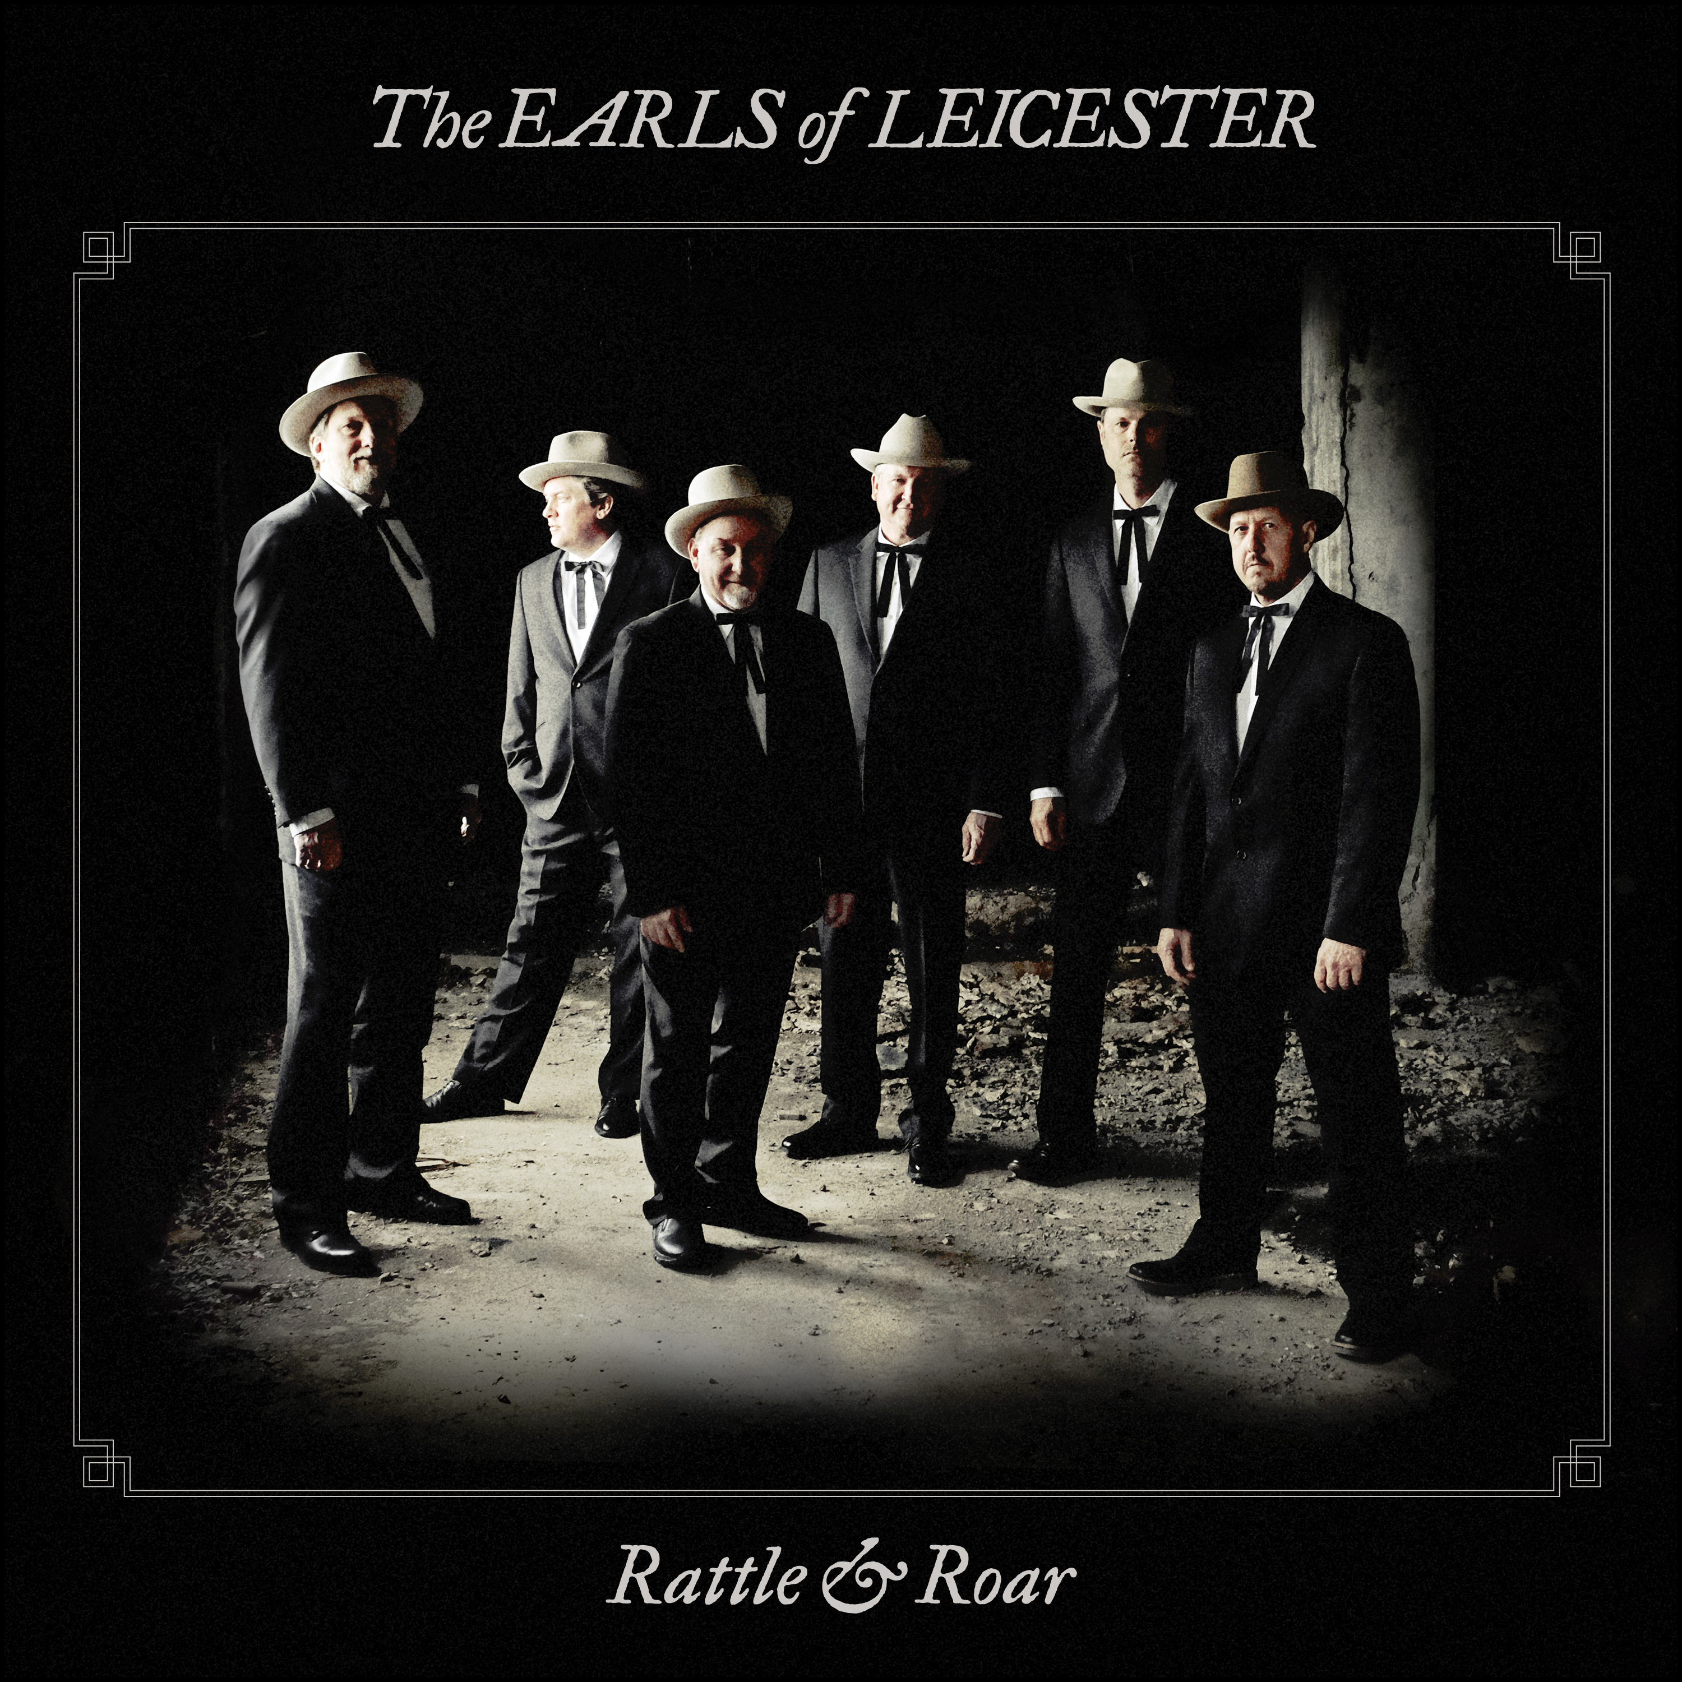
The Earls of Leicester
Rattle & Roar
Release Date: July 15, 2016

The Earls of Leicester have discovered a kind of magic that, when harnessed, allows moments once relegated to memories to roar back to life. Old sounds rattle loose chains of space and time that have kept us from forgotten joys and who we once were. Suddenly, as we listen to and watch the Earls pick, saw, and croon, instead of contemplating once upon a time, we are living it.

“Many audience members have come up to me after a show and said, ‘I thought that sound was gone,’” says Dobro master Jerry Douglas, the group’s founder. “And that’s just how it struck me when the band rehearsed the first time. I hadn’t heard that sound since Flatt and Scruggs––experienced that meeting in the air of those notes in that particular way. It’s an emotional experience.”

The Earls’ lead vocalist Shawn Camp remembers that first rehearsal just as well. “Only eight bars into the music I had to stop everybody because it made my hair stand up––it was so close to what Flatt and Scruggs sounded like,” he says.

With their second album Rattle & Roar (Rounder Records), the Earls have conjured up a fresh batch of Lester Flatt and Earl Scruggs songs, delivered with the Earls’ now signature blend of homage, virtuosity, and perspective. The inimitable Douglas remains the band’s producer and hypnotic Dobroist; blue-ribbon songwriter, singer, and producer Camp still soars on lead vocals and guitar; revered multi-instrumentalist and sideman Jeff White now deftly handles high harmony and mandolin; ace Nashville banjoist Charlie Cushman tackles banjo and guitars; topflight musician Johnny Warren cuts in radiantly on fiddle; and the esteemed Barry Bales, a longtime bandmate of Douglas in Alison Krauss and Union Station, holds magnificently steady on vocals and bass. “It’s like the band was predestined to come together,” says Camp. “We all love it. From the very first note of our show, I look around and everybody’s got a smile on their face. There’s just something about the music that makes you feel good.”

The band released its eponymous debut in 2014 to immediate acclaim, including the 2015 Grammy for Bluegrass Album of the Year and sweeping wins at the International Bluegrass Music Association Awards. It became overwhelmingly clear that 21st century listeners couldn’t get enough of the Earls’ recreations of songs sown by a pioneering duo more than half a century ago.

When asked what it is about Flatt and Scruggs that audiences still seem so hungry to hear, Douglas doesn’t hesitate. “I think it’s a combination of the music itself and the show,” he says. “We have sort of morphed into their show as well––the way we MC it.” At an Earls’ show, straightman intros and sly asides transform the spaces between songs into a tap-dancing combination of context, comedy, and history lessons, all inspired by the Foggy Mountain Boys, Flatt and Scruggs’ band formed in 1948 and active until 1969. “I go out on some pretty strange limbs myself because I know that Shawn, my foil on stage, will sound so much like Lester Flatt when he MCs,” Douglas says. “He’s the real thing. So I say some pretty off-the-wall stuff.”

Live, the Earls also take turns rushing in for solos. Douglas describes his and his bandmates’ hotfooting in vivid detail, from Cushman “creeping up the middle” to Warren’s deep-rooted antics. “Johnny will come swooping in from the side singing the quartet or come around the back and go between the singers to play a solo,” Douglas says. “There’s a lot of choreography employed on stage. Johnny does that because that’s the way his father did it, and that’s the way he’s going to do it.”

Warren’s father is the late Paul Warren, legendary fiddler for the Foggy Mountain Boys. The elder Warren kept a diary of songs and dates that the Earls mine for ideas, while all of the members also suggest material spurred by their own memories as well as old radio and live shows originally recorded on reel-to-reel tape.

Those collaborative deep dives into Flatt and Scruggs by some of the best living musicians––bluegrass or otherwise––built Rattle & Roar, a collection spanning exhumed nuggets and familiar favorites. To capture the feel of a live show, the album was recorded in one room, with all of the band members in a line, no separation between them. “This is about as live as a record can be. I hope listeners can hear the fun that’s going on,” Camp says. “They’re listening to everything go down, right then, at that moment. A lot of music can be made in an instant.”

Rattle & Roar pulses with impish joy and immediacy, uniquely showcasing artists at the top of their game as they delight in their work not just as creators, but also as fans struck with childlike awe. The songs’ themes of spirituality, love lost or found, war, and ex-convicts still resonate. “They can be rude too,” Douglas adds, laughing. “Take the first song on the record, ‘The Train That Carried My Girl from Town.’ It’s pretty violent. There’s some crazy stuff in there.”

Over thumping guitar, rolling banjo, chugging bass, Dobro that pleads and echoes, and rich fiddle, the album opener delights in furious revenge wishes delivered with naked sincerity. “I wish to the Lord that train would wreck / kill the engineer and break that fireman’s neck,” Camp confesses somewhat sweetly, then follows with plenty of other innuendo and lines sure to make listeners wonder if they heard him correctly.

“All I Want is You” is a showpiece, offering Camp a chance to croon. “Lester Flatt was sort of the Bing Crosby of this genre of music,” Douglas says. “He could have been a big band singer. He sang the entire melody, all changes, augments––they didn’t have to be whole notes. He really stretched, and so does Shawn. I love hearing him sing it.” Harmony-drenched “You Can Feel It in Your Soul” bounces with gospel fervor cushioned by warm strings, while “I’m Working on a Road to Gloryland” features multiple vocal bows worthy of a riverside revival. Instrumentals including “Flint Hill Special” and “Buck Creek Gal” are spirited back-and-forths between giants. “You can’t pretend or fake your way through this stuff,” Camp says. “It’s got to be right, or it’s wrong. And when we play together, it’s right.”

The lush instrumental “Steel Guitar Blues” was discovered on one of those old reel-to-reel recordings, as well as “Pray for the Boys,” the album’s solemn closer that hits just as hard today as when Flatt and Scruggs performed it in the 50s. It’s a fitting sendoff, brimming with feeling. Stunner “My Mother Prays So Loud in Her Sleep” features a room-shushing three-part vocal ascension that the Earls took pains to get right. “When we were rehearsing, we all got our heads together, listened to the original, and asked, ‘Okay, who is that on the high part? Is that Curly [Seckler] or Lester? We scoped in, and now, we’re sure it’s Lester,” says Douglas. “It’s things like that that we do together that make this band really work and exceptional.”

Every audience member who approaches the band after a show to reminisce or marvel is an integral part of the Earls’ very existence. “That’s part of what drives us to want to be close to the old style––just to see that excitement in those old people’s eyes,” Camp says. But as much as the Earls are a reincarnation of a sound that older generations have missed––an unexpected Proustian take on bluegrass––the band is especially interested in reaching new ears. “I hope people who don’t know Flatt and Scruggs hear this and think it’s totally new music,” Douglas says. “Then, I hope they find out what we’re doing and go out and buy every Flatt and Scruggs record they can find.”

