“People try it with guitars and they try it with computers, and nobody does it quite like this.”
PITCHFORK
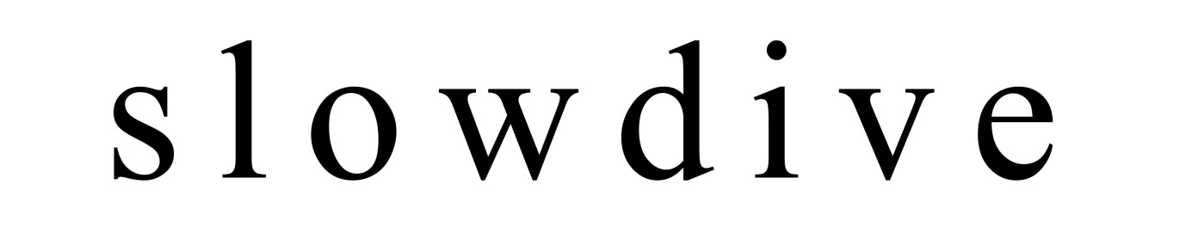
BIOGRAPHY
Slowdive are Neil Halstead, Rachel Goswell, Nick Chaplin, Christian Savill and Simon Scott. They formed in Reading in 1989 and signed to Creation Records, releasing three albums, ‘Just For A Day’, ‘Souvlaki’ and ‘Pygmalion’. Since their disbandment Slowdive have become one of the most cited bands of the early 90’s with the three albums appearing regularly in charts of the best records of the period.
21st May 1994, at Lee’s Palace in Toronto, Canada.
Slowdive finish their set and rather uncharacteristically for the time, Christian puts down his guitar, picks up a large union flag that he had been given (Britpop was at its height back then), held it aloft, and dived (slowly) into the crowd. Although no one knew it at the time, that was to be the last live performance of any kind by Slowdive.
Over the years, everyone went their separate ways, some staying in music and some not. In late 2013 the band met up in London to talk about the possibility of doing another record and some shows, really at first to see if anyone other than journalists were still REALLY interested.
18th May 2014
Slowdive make their first appearance in nearly twenty years for Sonic Cathedral at their tenth birthday celebrations at London’s Hoxton Bar & Kitchen. The response is almost overwhelming,
19th May 2014
Slowdive make their first official performance since reforming at a sold out (in three minutes) Village Underground in London. The response is truly overwhelming.
30th May 2014
Slowdive make their first festival performance of the summer, at Primavera in Barcelona. 25,000 people greet them and watch a set described by Drowned In Sound as ‘truly magnificent’.
June and the rest
Slowdive will visit Japan, Taiwan, Hong Kong, Singapore, the USA, Italy, France, the UK, Poland, Switzerland, Sweden, Finland, Belgium, Norway and Ireland over the coming months.

